**BUNN’S CHRISTMAS TREE TALE**

1. **Introduction**
2. **Background**

As a part of our Python Algorithm and Programming class, we are expected to create a comprehensive application or game to further deepen our knowledge about Python. The project has to be extended than what have been taught in class. In other words, this final project expected us to make an application that is not taught yet and it is outside our comfort zone to learn new concepts in Python and solve or debug the problems that we encountered during the creation of this specific application.

Hence, after some research, I decided to make a story game that focuses in a farm using Python, spesifically the Pygame module that isn’t taught in the course. I learnt it by reading the documentation in pygame.org and watching some Youtube videos. I also learnt how to make a map in Tiled and incorporate it in my game using PyTMX (Python Tiled Map XML) module that is also not taught in this semester’s course.

I was heavily inspired by the Youtube video that Clear Code made about Pydew Valley. I adapted some of the farming physics that he taught in his video in my game. However, my main point in making this game isn’t to let player to only experience a farm game, but I was more inspired to make a wholesome story that happens in a farm for player to experience during the Christmas holiday.

1. **Problem Identification**

The first thing that I decided to when I first thinking about my Python Algorithm and Programming Final Project is to make a simple game that can be solved only for like some minutes, but gives a rather useful information. My inspiration is to make a bite-sized simple game, like Google games (example: Google Doodle Champion Island, Pangolin Love, Black Cat Academy, etc.). So, after some thought, I decided to make a farm game, and the useful information that I picked for this game is a story to cherish your family and don’t let yourself drown in depression or other kind of sadness because life still continues. We have strived and do our best to not let the people that cares about us disappointed. The game is aimed only to be played for a few minutes, but will give players the useful information that is also fit in the holiday theme.

In the beginning of the game, player will be directed to an intro page and if player clicks the play button, then the game will be started. The game will be started by the first cutscene about the introduction of the story’s main character (Bunn’s) background story. Then, after each cutscene, there will be some simple tasks that the player has to accomplish, so that they can proceed the story. One of the tasks is to raise money and this can be achieved by farming and raising animals.

After the story, the player will get some money and a decoration will be blitted in the player’s house. Player can choose to continue playing the game (but there is no story anymore) or exit the game. The story is not too long too, so this will also let player feel that their time didn’t get wasted by playing this game.

So, my main objectives for creating this game are:

1. Let player experience a warm-hearted holiday story.
2. Let player draw a message from the story.
3. The player doesn’t have to waste that much time to experience the story.
4. **Project Specificiation**
5. **Game Name**

“Bunn’s Christmas Tree Tale”

The game is related to a Christmas tree and the main character’s name is Bunn. So, the game name is simply based on them.

1. **Game Flow Summary**

“Bunn’s Christmas Tree Tale” is a game where the player has to walk through the story of Bunn and how he get his Christmas tree. Player has to control Bunn to move around the map and doing things, like going to some places or raising money.

The player or Bunn can raise money by planting seeds, which is differentiated into two types (tomato and corn), cutting woods, or raising cows for their milks. Players can sell their crops (corns and tomatoes), woods, or milks by selling them to the merchant. Player has to use specific keys in the keyboard to moves around the map, toggle menus (inventory, help, and shop), and use specific tools.

Player also has to press only the key ‘C’ in their keyboard to start a cutscene. If the objectives or missions from the last cutscene is not completed yet, then the player can’t move to the next part of the story.

1. **Game Display**

The objects of this game are created using the sprite sheets from the Sprout Land assets, which are 2D pixel art assets. Meanwhile, the background is the map image that I created using Tiled and the tilesets that are also from the Sprout Land assets.

When player first opened this application, they will not be directed to the map instantly, but they will rather be directed to an intro menu with the background of a pixeled grass image. There will be also a play button and our main character’s Bunn. If player clicks the play button, then a cutscene will start.

Every cutscene display is divided into two parts, the main picture and the dialogue part. The main picture is about 550 – 700 pixels in height, showing the relevant pictures of what told in the story. Meanwhile, the dialogue part is also differentiated into two different types. The first type is the narrator’s line, which the background is a brown rect, while the second type is the dialogue of the character. The background of the second type of the dialogue is a dialogue box and the head profile of the character that is talking.

After that, there is the game default background, which is the map or the world as the background. There are many objects in this game background, from plants, trees, player, cows, merchant, houses, etc. However, there are also overlay display on bottom left and top right of the screen. On the bottom left, there is the display of the tool and the seed type that player currently uses. While, on the top right, there are two clickable menus. The first one is the inventory with cart symbol and the second one is the help menu about the keyboard shortcuts in this game with the question mark symbol. Both of them can also be toggled using the keyboard shortcut ‘P’ for inventory and ‘H’ for help.

1. **Game Physics**

Below are the explanations of the game physics that exists in the game:

1. Collision detection

Some objects like trees, plants, fences, and others have hitboxes, so that it can detect collisions. In this game, if a collision happens, then the player can’t move to that direction. For example, if the player crash or hit a tree when moving to the right, then the player can’t move to the right further. In this game, except objects that is derived from the class Generic, I also made some collisions in the map. The collisions can be seen through Tiled which it’s marked by red colour. With this, we can control player, so that they can’t walk on the water or walk out of the map.

1. Tree

If the player uses an axe and the target position is a tree object, then the tree will be cut. If the tree is cut, then the stump will be blitted on the screen rather than the tree because it is cut. There are two type of trees, the large one and the small one. Different trees have different sizes of stump. After that, if the player goes to sleep, then the tree will be reset. The tree will revive again (the stump surface will be replaced by the tree surface again) and player can chop it again.

1. Tilling Soil

Player can only till the soil if the player use hoe and the soil is farmable. If the soil is not farmable, example: soil tile that is near to water body or below a tree, then the soil will not be tilled. Tilled soil will lost it’s green color and changed color to brown as it is tilled.

1. Growing Plants

Every plant has four types of stage when they are planted. The first state is when they are still a little sprout. This stage occurs when the player first used a seed on a plantable soil. The second and third stage are the plants when they are still growing, while the last (fourth) stage is the stage when the plant is harvestable. Every seed has to be planted into a plantable or a tiled soil, if not, then the seed will not be planted and the amount of the seed will not be deducted. If the seed is planted, then it won’t grow even if the player resets it for several days if the seed is not watered. So, the player has to water the seed. If the seed is watered, then it will grow to become a plant on the next day. If the player watered it every day, then after several days, when the plant reach the fourth (harvestable stage), they can harvest it.

1. Harvesting Milk

The mechanism for harvesting milk is similar to the growing plants. The different is that when growing plants, we have to water it every day, but for getting milk, we have to feed the cow with grass every day. If the cow reached the max age, then we can harvest the milk by again giving the cow grass. The status of the milk (it is ready or not) can be seen by checking the milk bottle inside the cow farm. If it’s full, then the player can harvest the milk.

1. Weather (Rain and Sunny)

The weather system in this game is achieved by using the random library. The probability for a rain to happen in the game is 0.3 or 30%. If it’s raining, then the tilled soils will be wet, so the player doesn’t have to water the soil anymore. There will be also water drop that is blitted on the screen.

1. Day-night Transition

There is also a day-night transition in this game, so the sky will be darker along with the pass of time. If the player goes to sleep, the everything will be resetted, including the sky colour. The sky will become light again and if player plays for quite a long time, it will become dark again.

1. **Game Input**
2. Mouse left button, to click the play button in the intro menu, quit, or to click the overlay help and inventory menu on top right of the game when the game has started.
3. Keyboard keys:

* 'Esc' to quit the game.
* 'A' to move the player to the left.
* 'D' to move the player to the right.
* 'W' to move the player upward.
* 'S' to move the player downward.
* 'Space' to use current tools and if the merchant menu is on the screen, ‘Space’ is used to purchase or to sell something.
* 'Q' to switch current tool.
* 'J' to plant current type of seed.
* 'I' to switch seed with other type of seed.
* 'P' to open the player’s inventory menu.
* ‘H’ to open the help menu.
* 'O' to close the help menu, inventory menu, or merchant menu if they are active.
* 'Enter' to let player sleep (reset the day) if it is pressed near the player’s bed, open the merchant menu if it is pressed in front of the merchant, and to feed the cow if it is pressed inside the cow farm.
* 'Arrow' to navigate between items that are available when the merchant menu is active.
* 'C' to start a cutscene after doing some missions.
* ‘LCtrl’ to proceed to the next line of dialogue in a cutscene.

1. **Game Output**
2. Player image. The player has many kind of images based on what they are doing at the moment, from idle, using specific tools, and walking (based on the player’s input). The direction which they do something also determine which player image will be blitted to the screen. The images of the player are all contained in the ‘graphics/character’ folder.
3. Background image. The background image can be accesed through the ‘graphics/world’ folder which the name is ‘ground.png’.
4. Object images. The rest of the objects’ images like cuttable trees, flowers, fences, houses, cows, milk, stumps, and plants. are also in the ‘graphics’ folder, but in different type of folder based on their own name. The reason why they don’t exist in ‘ground.png’ because they are planned to have a hitbox, so that they can detect collisions.
5. Water and rain image. The water images can be accesed through the ‘graphics/water’ folder, while the rain image can be accessed through the ‘graphics/rain’ folder where the water and rain have several states (it is animated).
6. Button and overlay images can be accessed in the ‘graphics’ folder with their respective name. The button and overlay image is blitted on top of the screen, so that it will move around with the player.
7. Soil images. The default soils has the colour of green, but if it’s farmable and it is tilled by the player, then it will change its image. The brownish image is available in the ‘graphics/soil’ image. If the soil is further watered, then there will be also water on top of the soil. The water that is on top of the soil is one of the images in ‘graphics/soil_water’.
8. Cutscene images. The images for the dialogue box, character’s emoticon, and cutscene picture is available in the ‘graphics/dialogue’ folder where for every cutscene, there will be a specific folder for them based on their order.
9. Player’s money.
10. Player’s inventory. The list of items that player currently has can be accessed in the game by toggling the inventory menu. There will be also image for each item that the player has. The image for those are available in the ‘graphics/inventory’ folder.
11. Background music is in the audio folder and its name is ‘bg.mp3’.
12. Sound effects are also available in the audio folder. The sound effects in this game are

* When player using an axe to chop a tree (axe.mp3)
* When player buy something (buy.mp3)
* When player click on the play button in the intro menu or toggle the help and inventory menu (click.mp3)
* When the player press LCtrl to proceed to the next line of dialogue in a cutscene (cutscene.mp3)
* When the player feed the cows with grass (grass.mp3)
* When the player uses hoe to till soils (hoe.mp3)
* When the player harvest milk (milk.mp3)
* When the player plants a seed (plant.mp3)
* When the player sells something (sell.mp3)
* When the player acquired crops or woods (success.mp3)
* When the player waters a plant (water.mp3)

1. **Game Libraries (Modules)**
2. Pygame

Pygame is a set of Python modules to create a game. Used for creating the game window, the game objects and blitting them to the screen by using surface and rect, drawing text, playing sounds, and detecting collisions.

1. PyTMX

PyTMX or Python Tiled Map XML is a set of Python modules specified to load and handle map for games. So, we can easily edit our map in Tiled and use it in Pygame by utilizing PyTMX. In this game, PyTMX helped me to get the tile layer’s and object layer’s name and properties based on Tiled, so that I can use it in the program.

1. random

The random module in Python is a built-in module that is used to generate random choices or numbers. In this game, I used the randint and choice from the random module. The randint function is used to help generating the probability of a rain happening, while the choice function is used to choose one of the elements inside a list. The choice function is used when generating the water on top of the soil tiles and the water drop and water floor when it is raining.

1. os

Python has a built-in module, called the os module that contains methods to handle and interact with the operating system. In this game, I use the walk function from os module that generates the file names in a directory tree by walking the tree. I used it to help me to return the surfaces from the images in specific folder.

1. sys

The sys Python module provides various functions and variables to manipulate Python runtime environment. In this game, I use the exit function to exit the program when the player quit the game or pressing the ‘Esc’ key.

1. **Game Important Files and Folders**
2. ‘audio’ folder, contains the background music and the sound effects for this game.
3. ‘code’ folder, contains the Python code of this game.

* cutscene.py, contains the class CutSceneOne, CutSceneTwo, CutSceneThree, and CutSceneFour. Each of them is used to handle their own respective cutscene. cutscene.py also contains the class CutSceneManager to manage cutscene and update the status of a completed cutscene.
* game_display.py, contains the class Display that is used to manage all the game functions and displays if the player has started the game and the class CameraGroup to move the camera based on the player movement, so that the player is still on the center of the screen.
* game_settings.py, contains the constant values of some variables that are used in the game, like the screen width, screen height, and many more.
* intro.py, contains the class Intro that is used to draw and manage the intro menu screen (the display screen before the player starts the game).
* main.py, contains the class Game that is used to handle methods to run the game (contains the game loop).
* merchant_menu.py, contains the class Menu that is used to handle the merchant shop, so that the player can buy and sell something through the shop menu.
* overlay_menu.py, contains the class Overlay_Menu that handles the help menu display and the class Inventory that handles the inventory menu. Both of them are displayed overlay on the screen, that’s why they are in the same file.
* overlay.py, contains the class Overlay that is used to handle the images on the bottom left of the screen that represents the current used tool and current type of seed.
* player.py, contains the class Player that handles the player’s movement, animation, tool usage, collisions, and many more that is related to the player.
* sky.py, contains the class Sky that draws a darker sky by the pass of time, the class Drop to handle the movement of the rain drops and its lifetime, and the class Rain to create the rain drops on the screen and update it.
* soil.py, contains the class Plant to handle methods for growing plants, the class SoilTile as the tilled soil tiles after player uses a hoe, the class WaterTile as the water on top of the soil tiles after player waters the soil tiles, and the class SoilLayer to handle methods of tilling and planting in the game.
* sprites.py, contains the class Generic for every kind of objects in the game. Besides Generic, there are also the class Interaction, Water, Particle, Tree, and Animal which are all inherited from Generic.
* The class Interaction is used to handle non-visible objects but player can interact with them, for example, in front of the merchant, besides the bed, etc.
* The class Water is used to draw waters and animate them.
* The class WildFlower is used to draw wildflowers.
* The class Particle is used to draw Particle when a crop is harvested.
* The class Tree is used to handle method that is related to a cuttable tree.
* The class Animal is used to draw and animate the cows.
* support.py, contains the class Timer to know and handle the duration of a player when doing something and the class Button to handle and draw button on the screen.
* transition.py, contains the class Transition to draw the transition if the player goes to sleep and reset the day.

1. ‘data’ folder, contains the .tmx file map for this game’s ground background and several .tsx files inside the tilesets folder. The .tsx files are used in the process to create the complete map in the ‘map.tmx’ file.
2. ‘document’ folder, contains the documentation (report and diagrams) for this project.
3. ‘font’ folder, contains the font types that are used in the game.
4. ‘graphics’ folder, contains all of the game picture assets. The ‘graphics’ folder contains 16 different folders that are all the pictures or sprites for the game. The folders are ‘animal’, ‘button’, ‘character’, ‘dialogue’, ‘environment’, ‘fruit’, ‘inventory’, ‘milk’, ‘objects’, ‘overlay’, ‘rain’, ‘soil’, ‘soil_water’, ‘stumps’, ‘water’, and ‘world’. The ‘environment’ and ‘objects’ folder contains the images to create the tilesets in the previous ‘data’ folder, meanwhile the rest besides of them are images that are going to be blitted on the screen when the game runs.
5. ‘story’ folder contains four .txt files that are the story or the narration for each cutscene of this game.
6. **Solution Design**
7. **Design Choices**

For this game, I wanted to have a light-hearted and cute character as the main character. The game atmosphere should also be light-hearted and casual, so that the player can experience a warm-hearted story in this casual game.

For the image design, I decided to use the online free spritesheets assets from Sprout Land for my project because the character and the game elements are cute as I intended to. They also have more free assets than the other farm assets that I have searched. Below are the image of the Sprout Land assets.

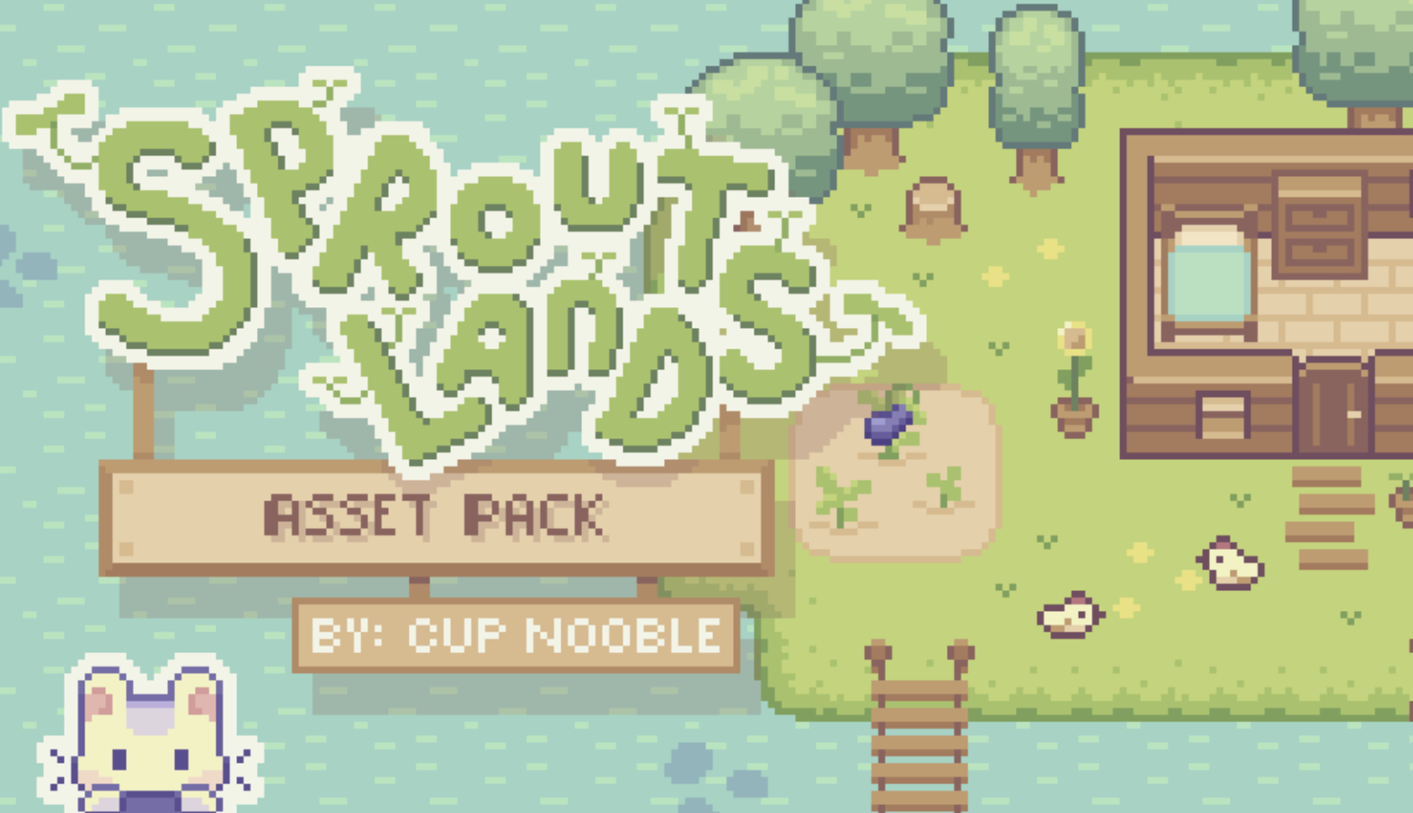

Source: https://cupnooble.itch.io/sprout-lands-asset-pack

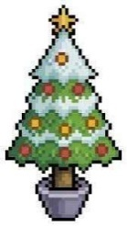The only object that I didn’t use from this assets pack is the Christmas tree and the Christmas hat which are shown below.

Source: https://www.istockphoto.com/id/vektor/pohon-natal-seni-piksel-dengan-ikon-vektor-bintang-dan-pernak-pernik-untuk-game-8bit-gm1431396087-474006614



Source: https://www.freepik.com/premium-vector/santa-hat-pixel-art-style_35166269.htm

From the assets pack that I have downloaded, I then create a map in Tiled for the world environment for this game. The map can be seen below. The green tiles are the farmable tiles (the tiles that can be tilled), while the red tiles are the collision tiles (player can’t walk across these tiles). The fence is not marked as collision tiles because the fences will be generated as a Generic object later and Generic object has hitbox.

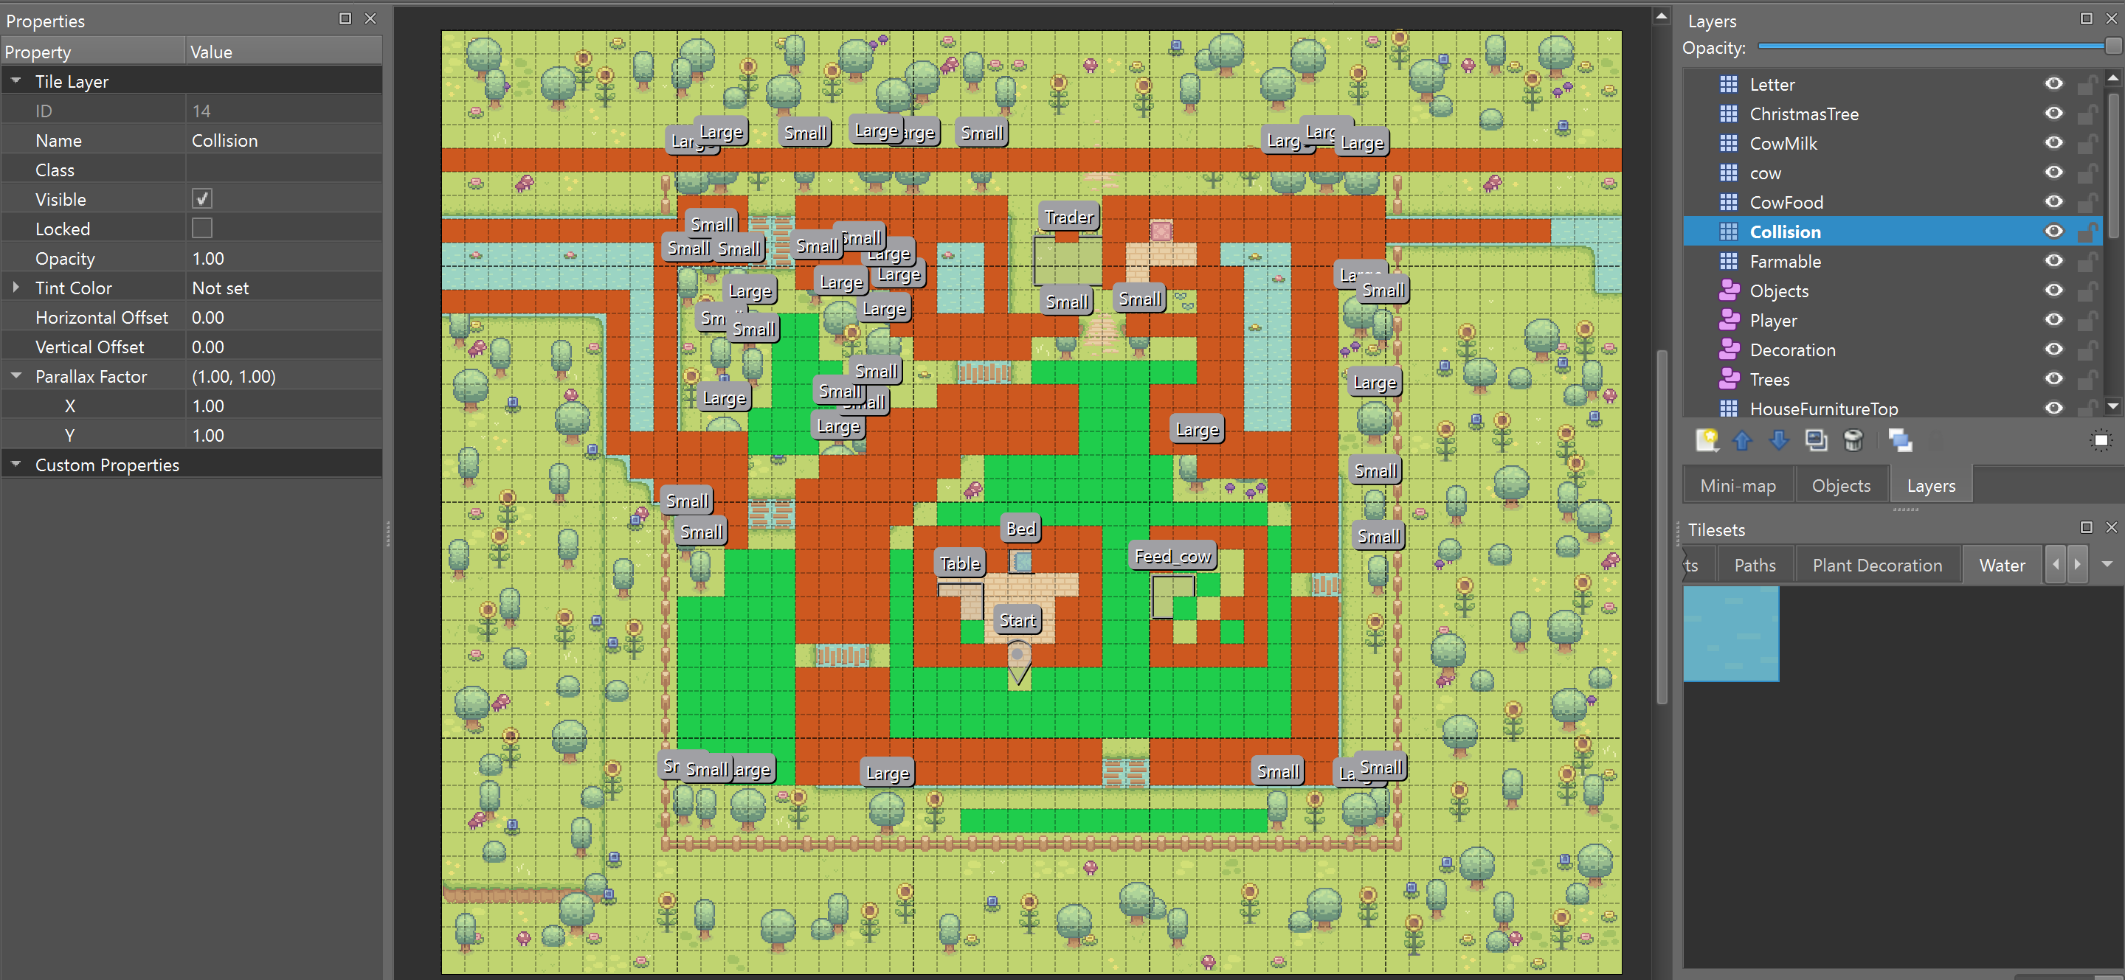

Below are the map’s appearance if the collision and farmable tiles are not visible. The red and green tiles inside the cow farm and Bunn’s house is not the farmable and collision tiles.

The red tile inside the house is for the Christmas tree, while the green one is for the letter. Meanwhile, the green tiles inside the cow farm is for the cows and the milk bottle, while the red one is for the cows’ food.

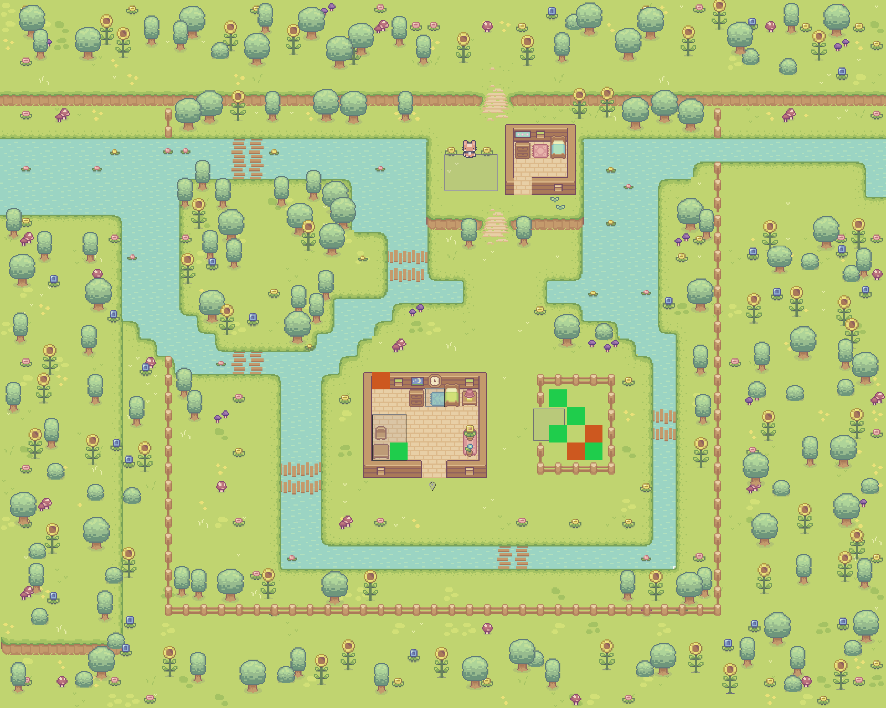

Result

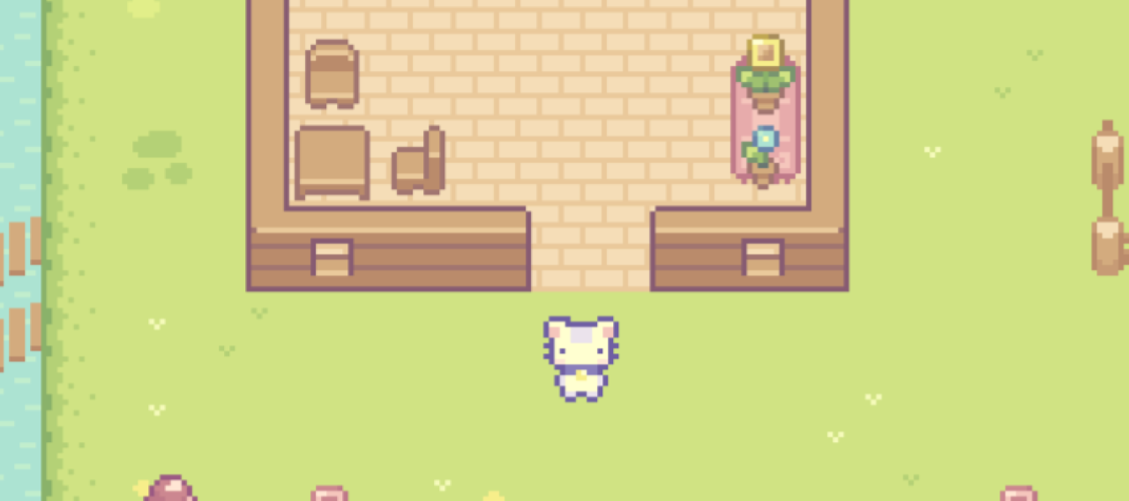

1. **Font and Sound**

The font that I used for this project are LycheeSoda and Rubik (Bold and Semibold). LycheeSoda is used mostly in the game because it’s in pixel style, so it is very suitable for the overall design, while Rubik is only used for the help menu because I think that the help menu should have a straighter and easier to see font, so that the player can read it more easily.

Source for LycheeSoda: https://www.dafont.com/lycheesoda.font

Source for Rubik: https://fonts.google.com/specimen/Rubik?query=rubik

Meanwhile, for the sound, as I said before, I wanted to have a light hearted song, so I chosen a light hearted background music created by MusicTown from Pixabay (https://pixabay.com/music/search/light-hearted/) and rename it to bg.mp3.

And below are the sources for the other sound effects that I have used throughout the game:

* axe.wav

Source: https://www.soundsnap.com/axe_impact_hit_wood_blastwavefx_26204

* buy.mp3

Source: Pixabay from Pixabay (https://pixabay.com/sound-effects/coin-c-02-102844/)

* click.mp3

Source: UNIVERSFIELD from Pixabay (https://pixabay.com/sound-effects/interface-124464/)

* cutscene.mp3

Source: UNIVERSFIELD from Pixabay (https://pixabay.com/sound-effects/button-124476/)

* grass.mp3

Source: https://www.youtube.com/watch?v=4eVmKIfZFpY

* hoe.mp3

Source:https://www.videvo.net/sound-effect/hoe-chop-dirt-grub-soil-pehd069902/247265/#rs=audio-download

* milk.mp3

Source: https://www.youtube.com/watch?v=3aOnFCVz9iY

* plant.mp3

Source: Pixabay from Pixabay (https://pixabay.com/sound-effects/21-seed-46670/)

* sell.mp3

Source: Pixabay from Pixabay (https://pixabay.com/sound-effects/cash-register-fake-88639/)

* success.mp3

Source: https://www.zapsplat.com/music/retro-80s-arcade-game-jump-8/

* water.mp3

Source: Pixabay from Pixabay (https://pixabay.com/sound-effects/pouring-drink-sound-effect-by-rea-102018/)

1. **Essential Algorithms**
2. **game_settings.py**

This file includes the constant variables that will be used throughout the game. Below is the explanation for the code in this file.

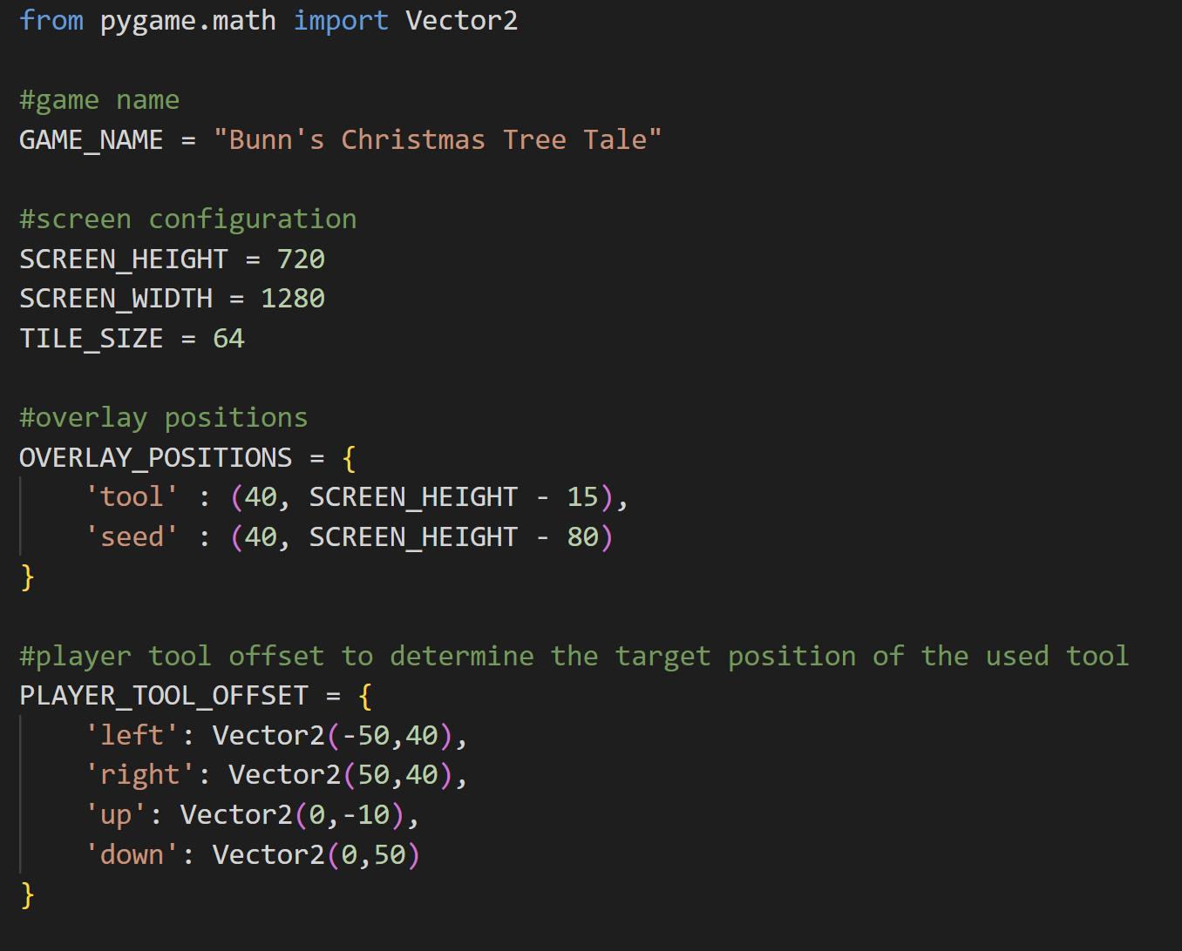

First of all, I imported Vector2 from pygame.math. Vector2 is used to define a two-dimensional vector.



The first constant variable that I define is the game’s name which is Bunn’s Christmas Tree Tale. The game circles around Bunn and his story with the Christmas tree, so I think this is a suitable name for this game.



These three variables are the screen and the map’s tile size for this game. The window’s dimension is 1280px x 720px, while the tile size is 64px. So, for every tile in map.tmx, when it is blitted on the screen when this game runs, the size will be 64px x 64px.



This dictionary defines the position of the overlay pictures of the tool and the seed. As we can see, it is positioned on the bottom left of the game window.



This dictionary defines the tool offset as when the player faces up, down, left, or right. This tool offset will be used to determine the target position when the player uses a tool.

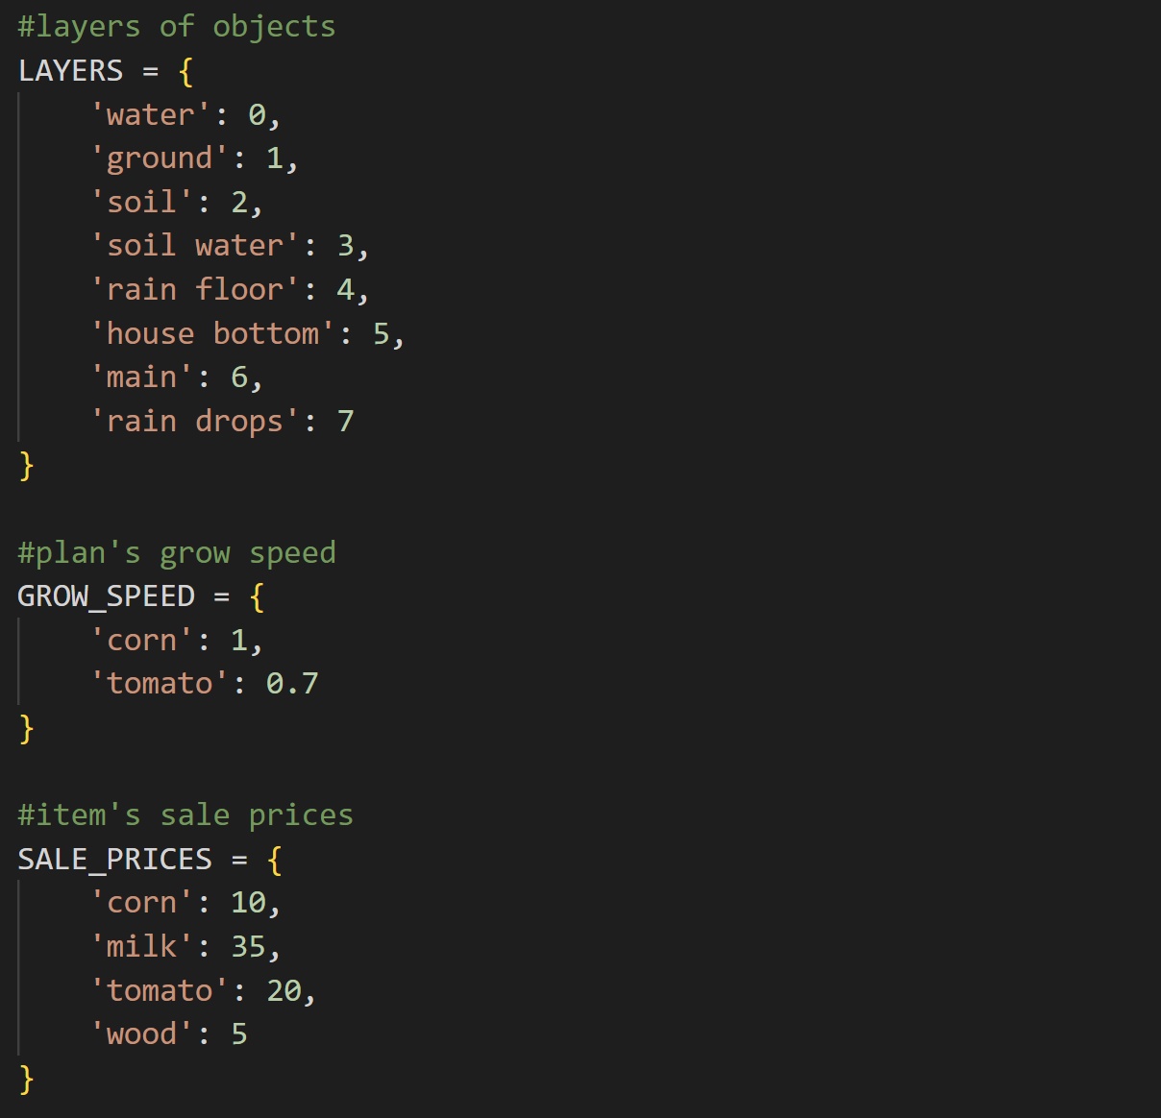

This dictionary contains the layer value of each kind of object in this game. The highest the value, then it will be blitted more top. Most of the object in this game is blitted in the ‘main’ layer.

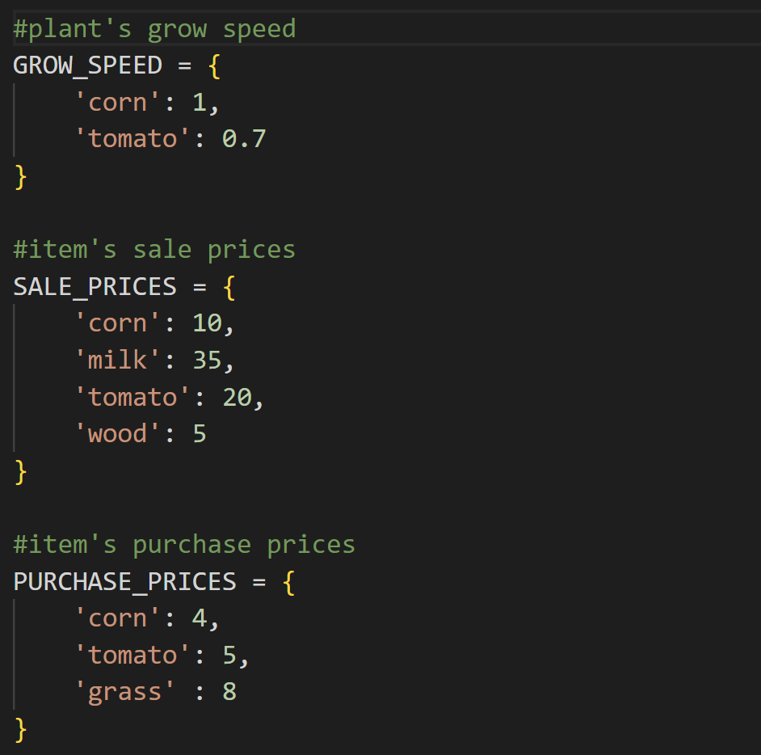

This dictionary contains the growth speed for each plant in this game, which is corn and tomato. The lower the number, then the slower it will grow. In this case, corn grows faster than tomatoes.



This dictionary contains all the sale prices for the items in this game. If a player sells an item to the merchant, then the sale price of the specific item will be added to the player’s money.



On the contrary, this dictionary contains all the purchase prices of each item in the game. So, if the player buys something, then the purchase price of each item will be deducted from the player’s money. The corn and tomato here are also not the plants, but rather the seeds.

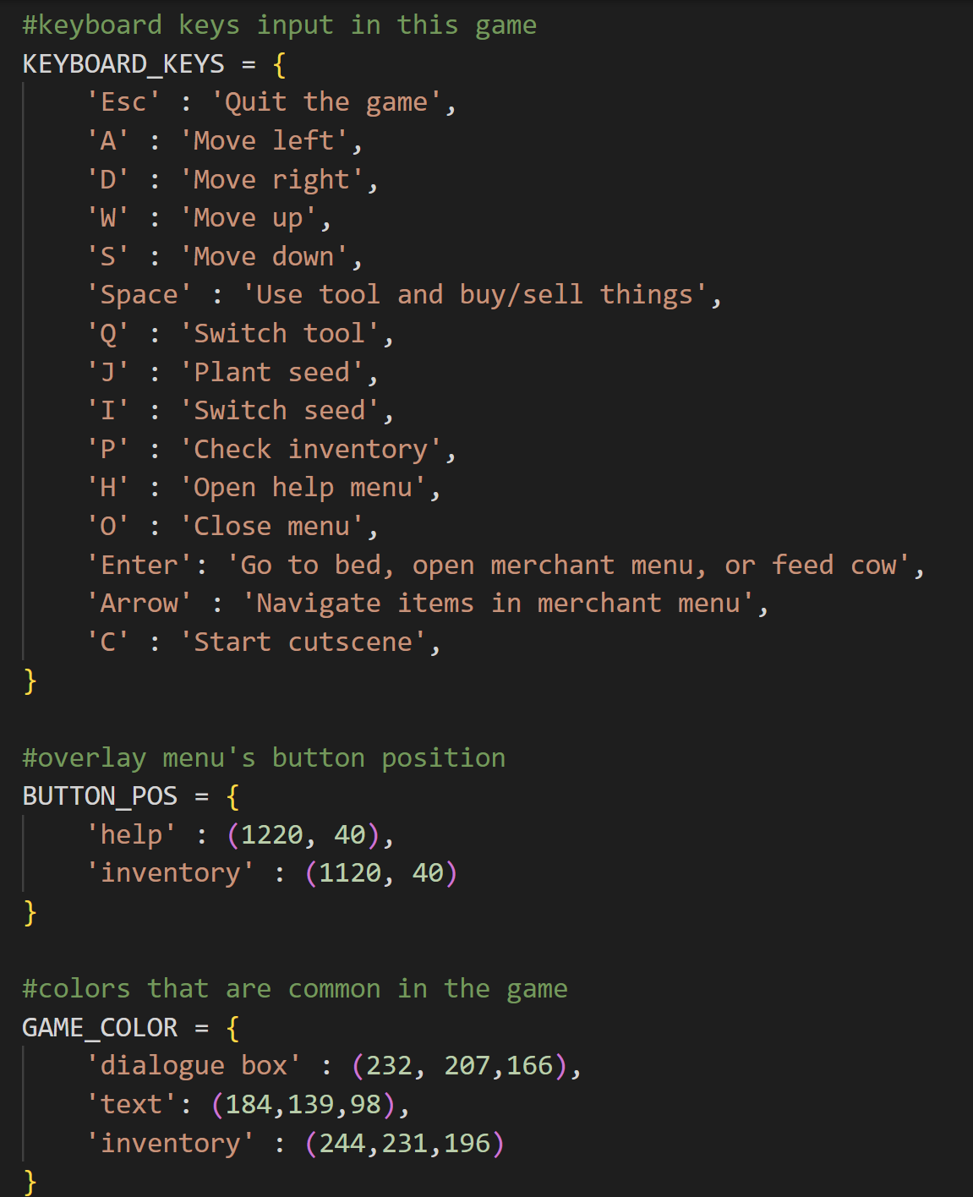



Next, it’s the KEYBOARD_KEYS dictionary. This dictionary contains the keyboard shortcuts in this game when the cutscene is not running. If the cutscene is running, then the only key that the player can press to update the game (cutscene) is the LCtrl key.



This dictionary contains the help menu and inventory button position. The position of both of them is on the top right side of the screen or window.



This dictionary contains three different shades of brown colour. These brown colours are commonly seen in the game, so for convenience, I also include them in this file.

1. **cutscene.py**

This file contains the classes CutSceneOne, CutSceneTwo, CutSceneThree, CutSceneFour, and CutSceneManager. So, this file is specially used to manage cutscenes in the game.

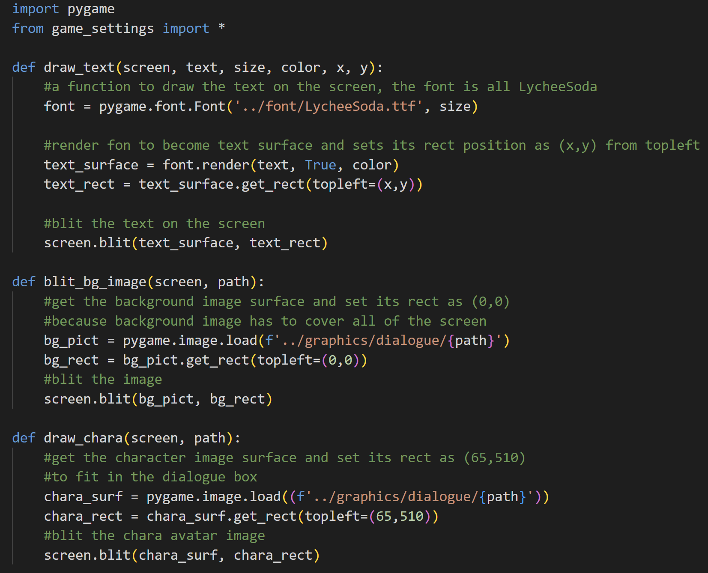

Import pygame and all constant variables from game_settings.

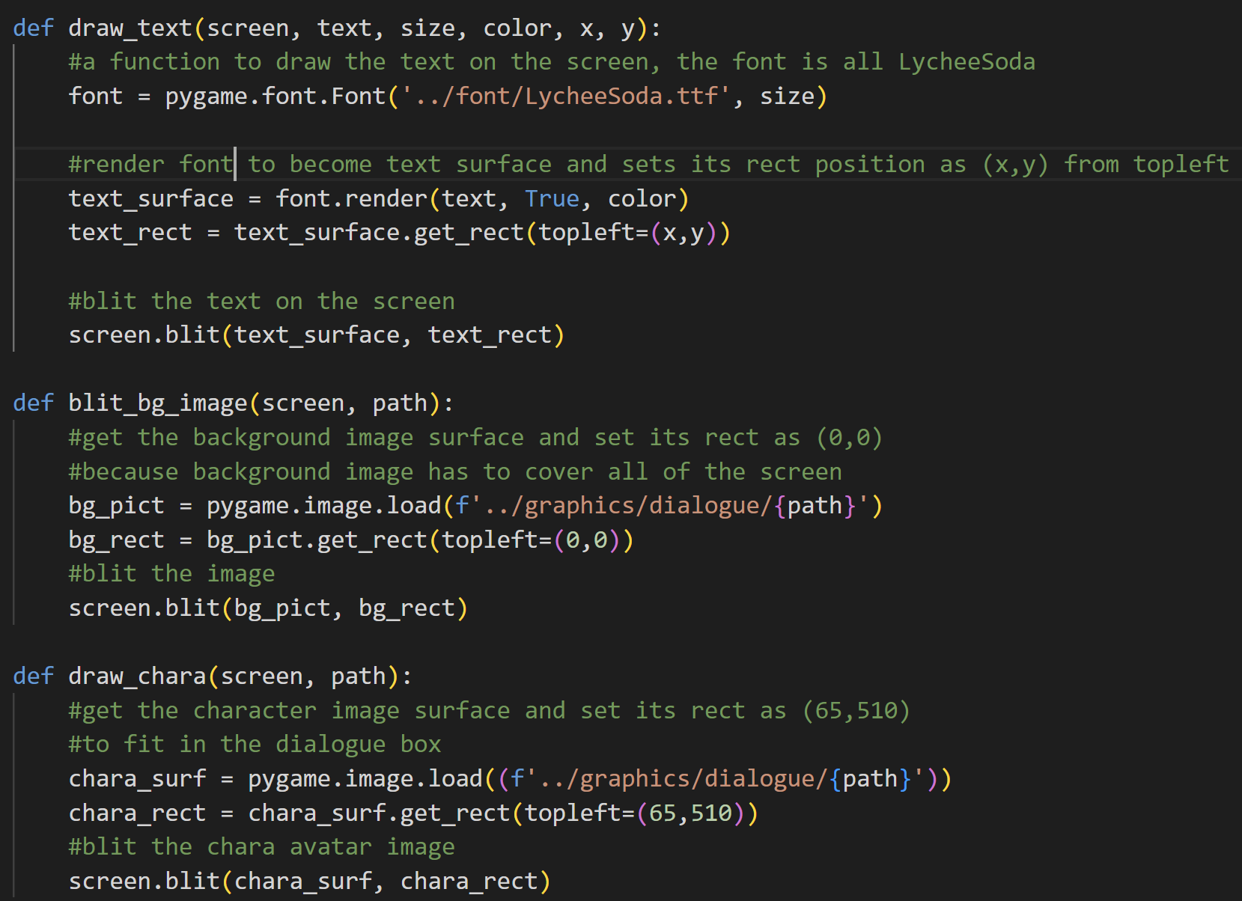

The draw_text function is used to draw the text on the screen. First of all, the function will create a new font object with the type of LycheeSoda and the size that is passed to the function. Next, it will make a text surface by rendering the font with the text that is passed to the function. Then, it gets the rect and sets its position. After that, it will blit the text surface based on the text rect position on the screen surface.



The blit_bg_image function is used to blit the background image on the screen. It will first load the background pictures as a surface based on the given path. Then, it will get the rect. As it is a background image, so I set the position to start from (0,0). After that, it will blit the background image on the screen based on the rect’s position.



The draw_chara function is used to draw the avatar icon of the character that is speaking on its box inside the dialogue box. First off, it will get the character image surface based on the given path. After that, it gets its rect and sets its position based on the location of the box. Lastly, this function will blit the surface on the screen.

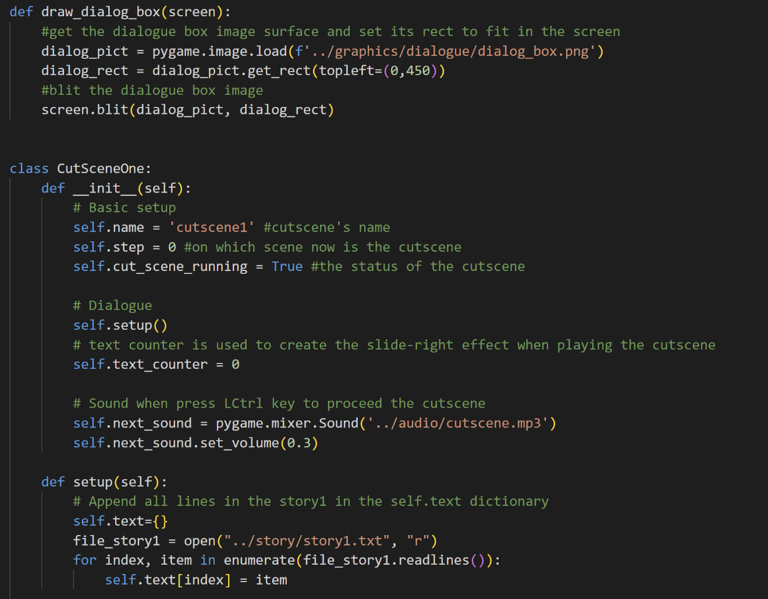

The draw_dialog_box_function takes on one parameter which is the screen. It also has a similar workflow as the other functions before it. It will first get the dialogue box image surface and then set its rect so that it will fit on the screen. After that, it will blit the dialogue box surface on the screen.

* Class CutSceneOne

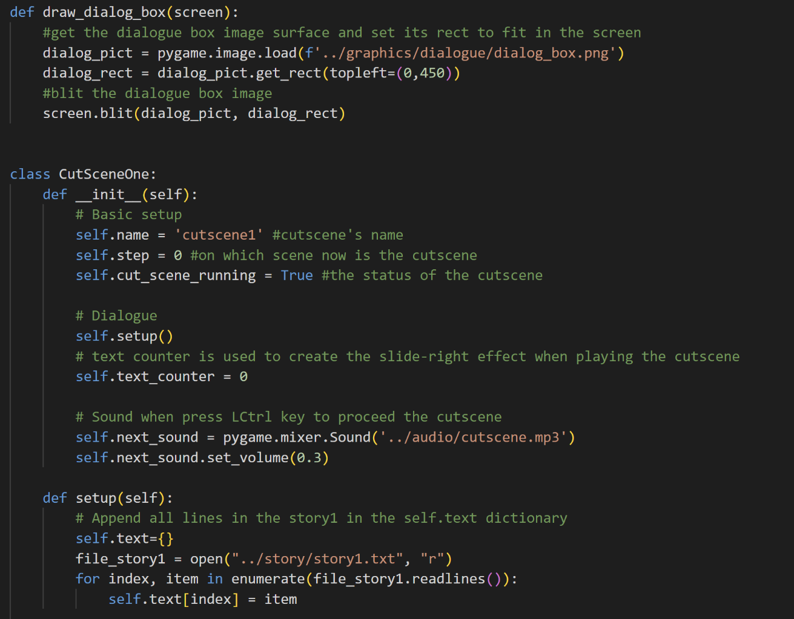

The __init__ function is called when a new object is created from this class. The class CutSceneOne __init__ function has the attribute name, which is ‘cutscene1’, then by default (because the cutscene hasn’t started yet), the step will be 0. The step is on which scene or which line the cutscene is now. Also, the status of the cut_scene_running will be True when CutSceneOne is initialized, so it will automatically play the cutscene.

Next is the text counter. The text counter will be used to create a slide-right effect of the text when we play the cutscene. The default value will be 0 because we want to start the slide right from the first character in the line. And then, there is also the next_sound which is the sound effects that will be played when we press the LCtrl key to proceed with the cutscene. Here, I also lower the volume by setting the volume to 0.3.

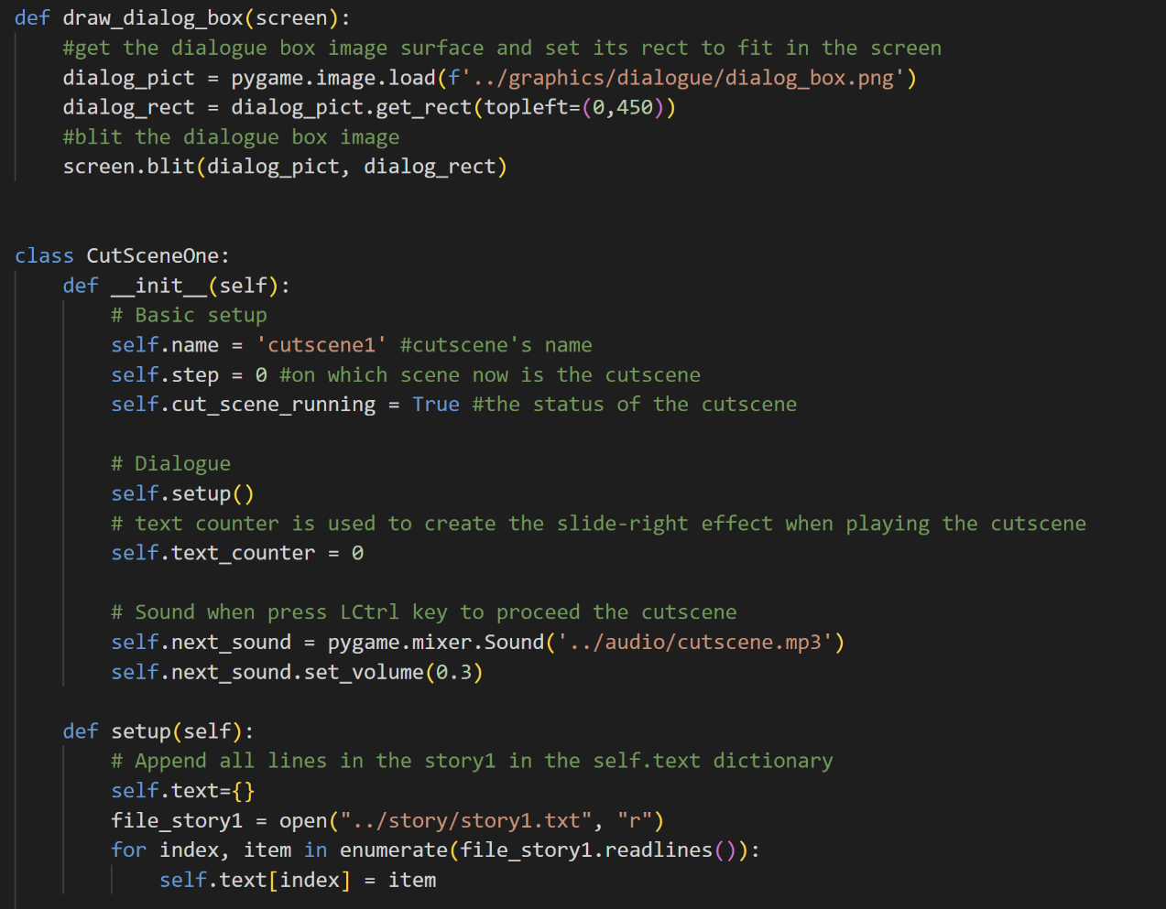

In the previous __init__ function, we also call the setup function. So, basically what the setup function does is read all the lines in the txt file of the story and then make a new key:value pair in the self.text dictionary. The key will be the index and the value will be the line of dialogue (string).

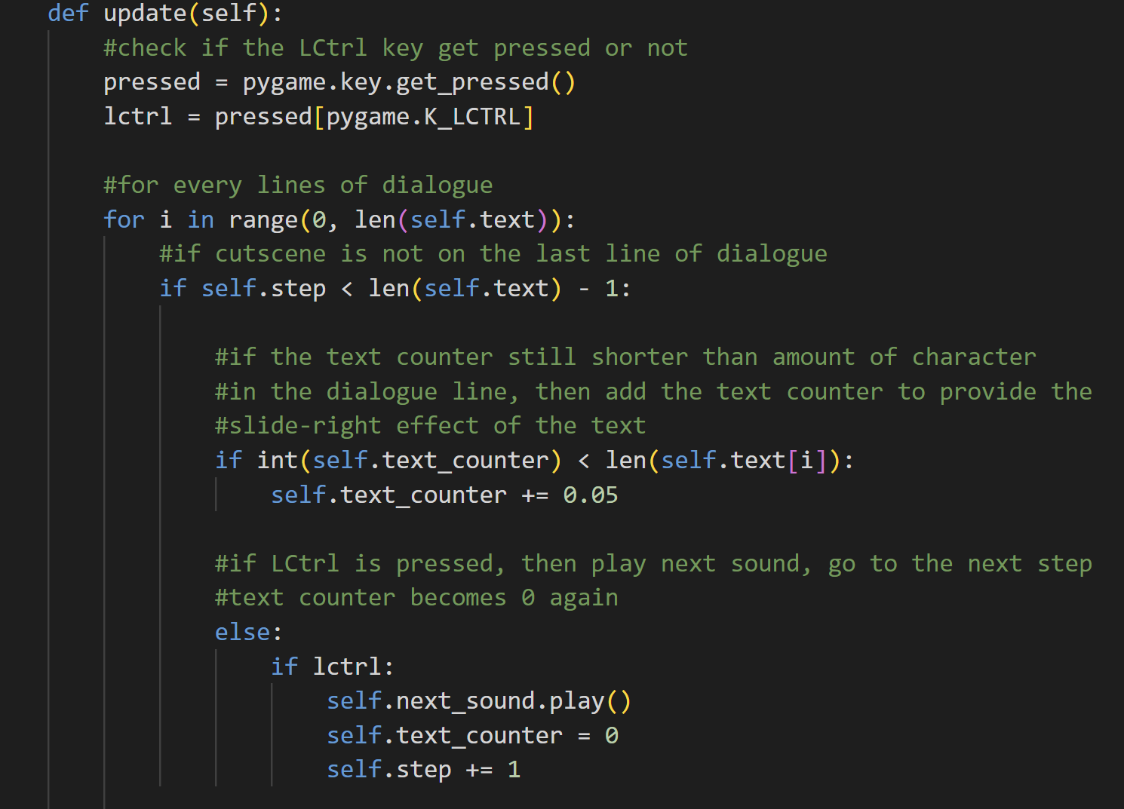

Next is the update method. First off, we will check if the LCtrl key is pressed or not. Then, for every line of dialogue, if the cutscene is not on the last line of dialogue, then it will perform the text slide right animation of the dialogue line. This animation can be achieved by using the text counter. If the text counter is still shorter than the number of characters in the dialogue line, then add the text counter until it reaches the end of the dialogue line. If LCtrl is pressed, then play the next sound, the text counter will become 0 again (so that the next dialogue line can have the slide right animation too), and then go to the next step or the next line of dialogue.

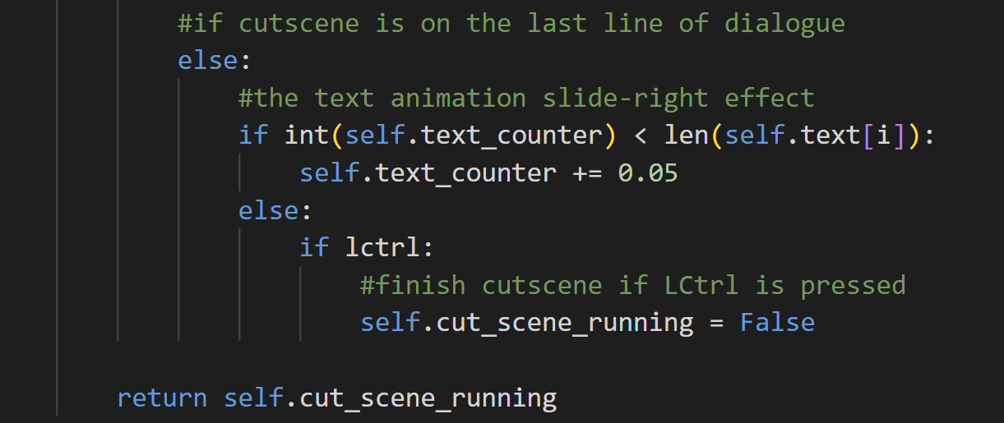

Else, if the cutscene is already on the last line of dialogue. It will also perform the slide-right animation effect. But upon pressing LCtrl, the cutscene will be finished and the status of cut_scene_running will be False.

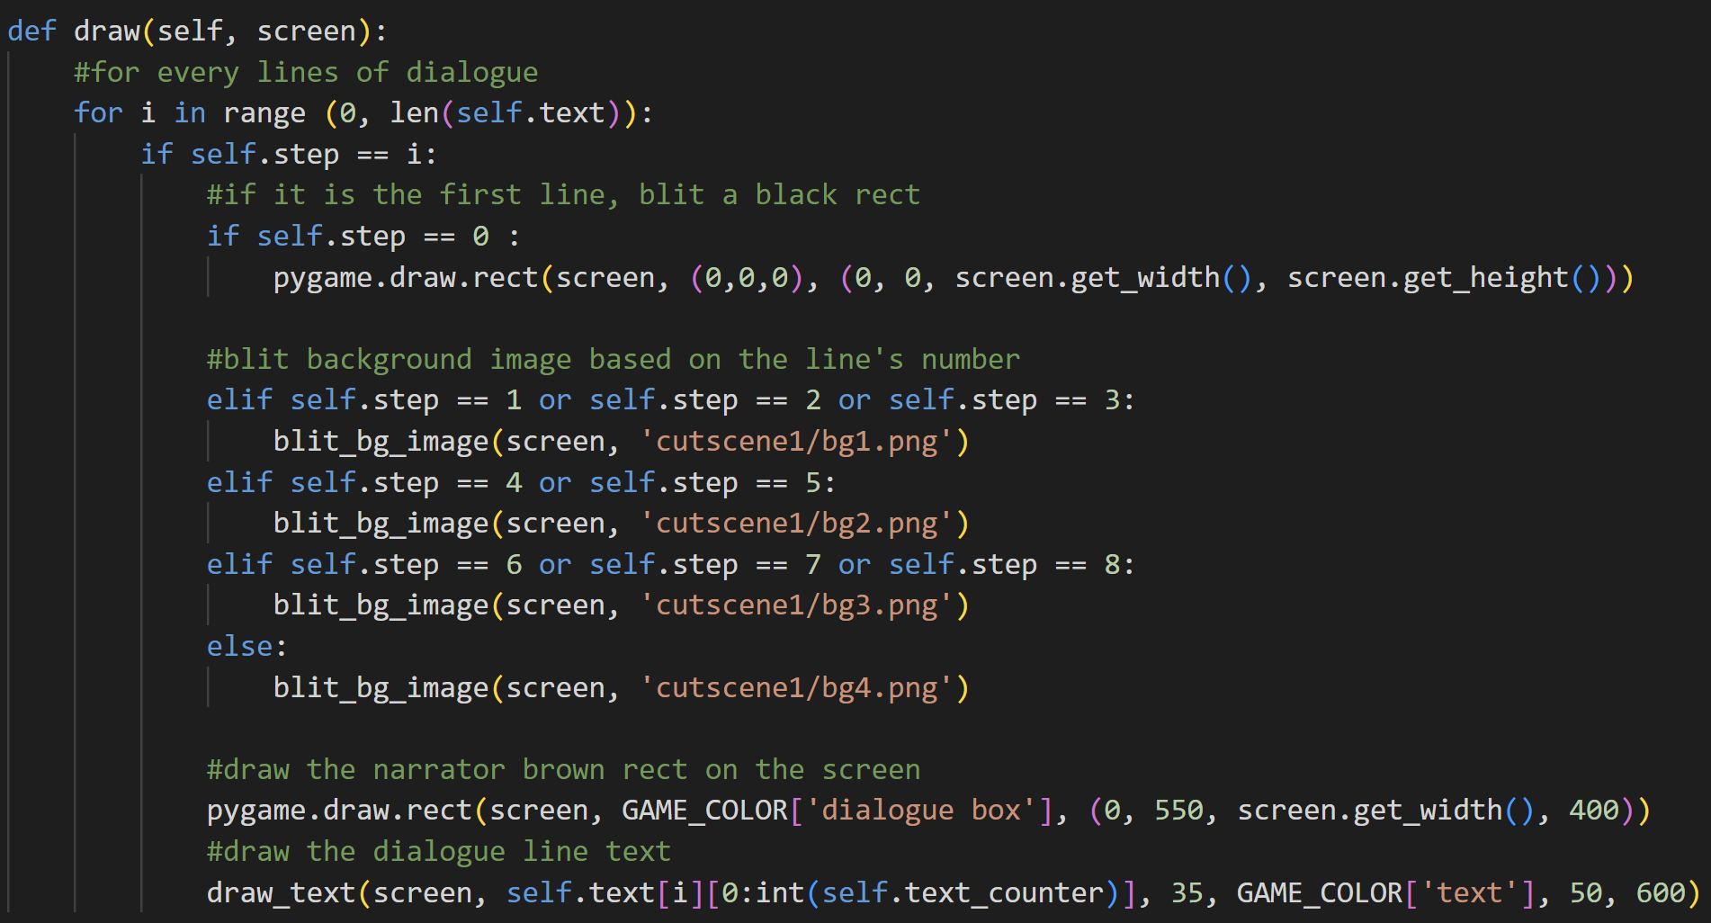

The last method of this class is the draw method. The draw method is specialized to draw the background picture of each scene in the cutscene and also the dialogue or the narrator box, and the dialogue text. So, for every line of dialogue, if it’s the first line, then draw a black rect as the background image. If that’s not the case, then blit the background image based on the line’s number or the step because each line of dialogue has a different scene. Lastly, it will draw a narrator box (rect) and the text for each dialogue’s line. The first cutscene doesn’t have any dialogue or monologue, only narrator lines, that’s the reason why we only need to draw the narrator box for every line of dialogue in this cutscene.

* Class CutSceneTwo

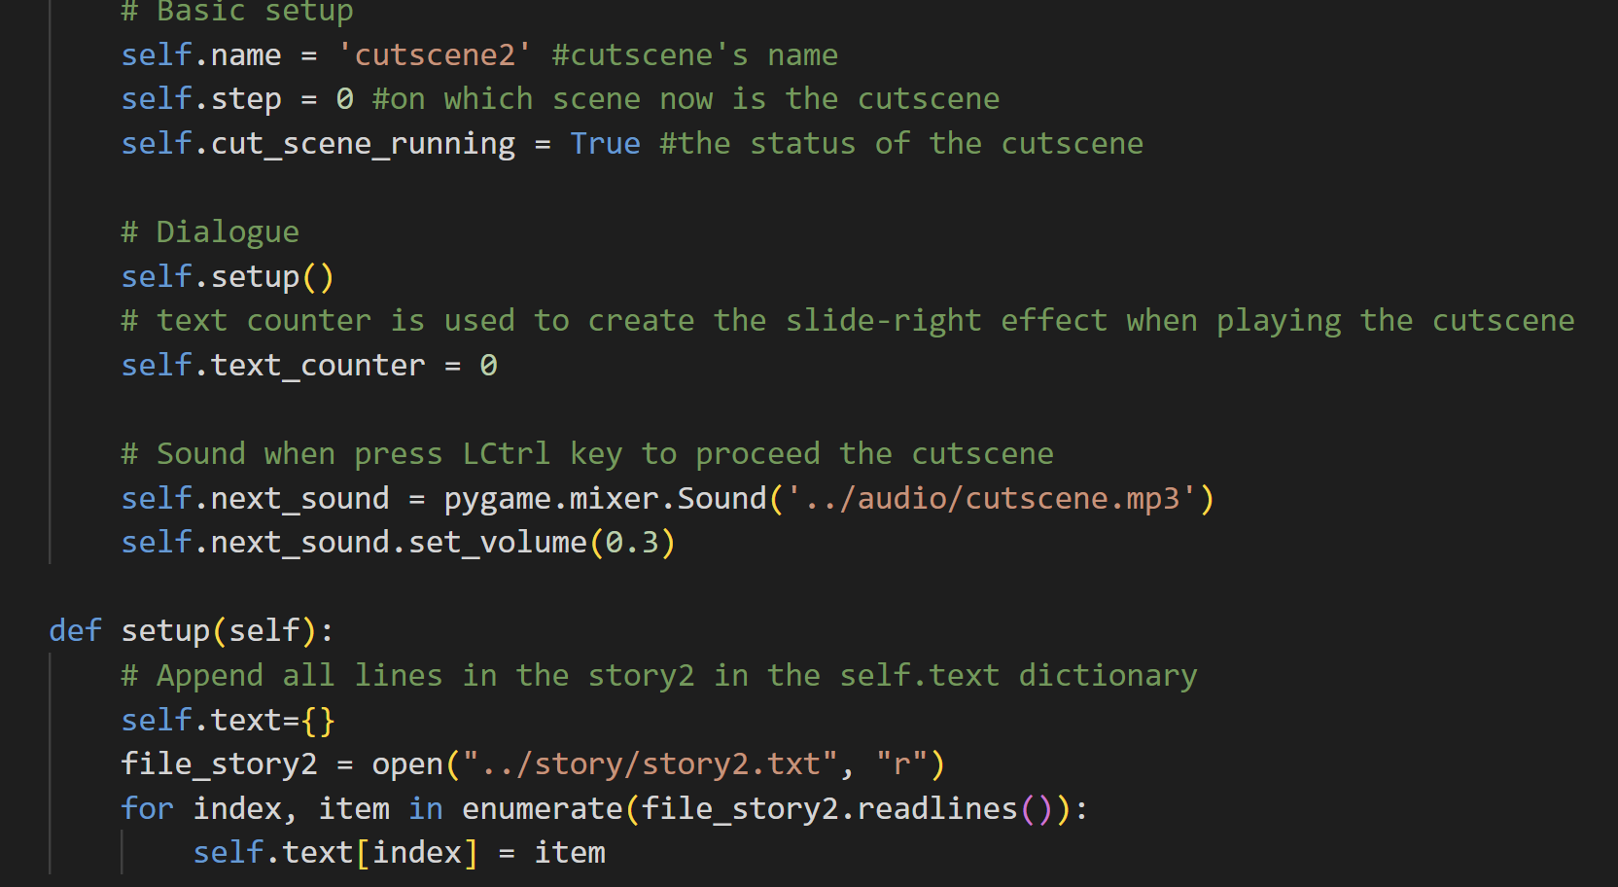

CutSceneTwo is very similar to CutSceneOne. It has the same attributes as CutSceneOne, the only difference is its name is cutscene2.



It also has four methods which are the __init__, setup, update, and draw. The setup method is slightly different because it gets the lines from another txt file. The main difference between CutSceneOne with CutSceneTwo and also with the other cutscene classes is the draw method.

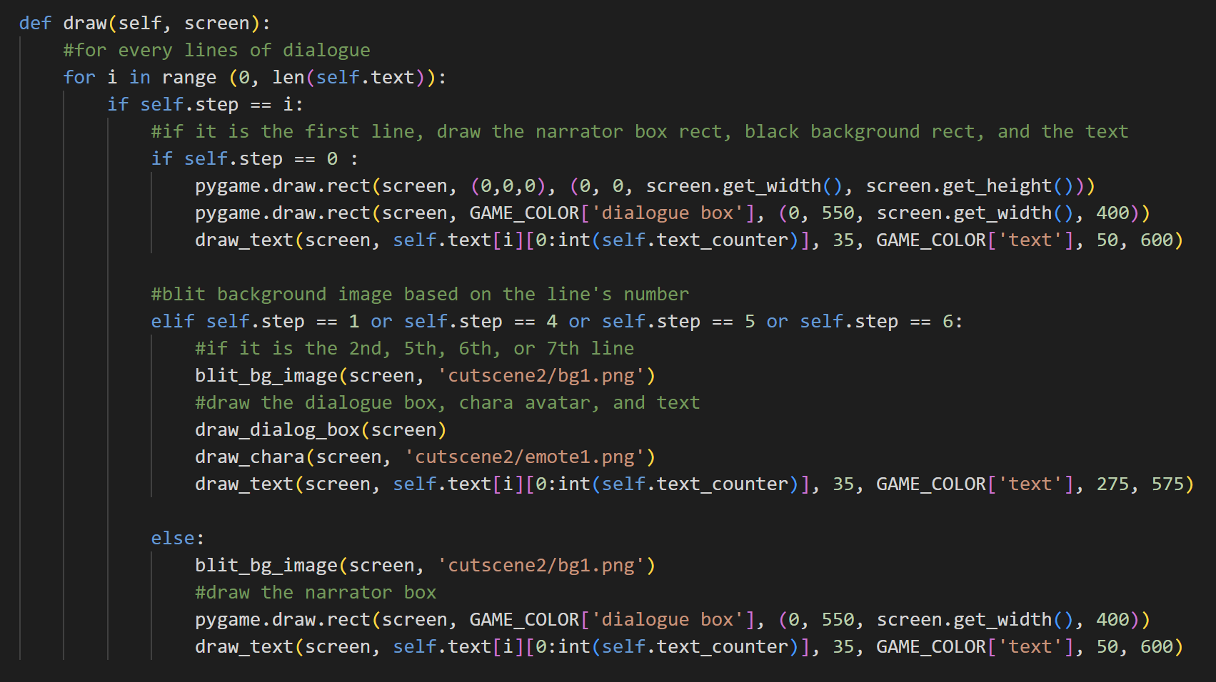

For every line of dialogue, if it’s the first line, then draw the narrator box, black background image, and the text. But, if it isn’t, then draw the other background images. And if it is the second, fifth, sixth, or seventh line, then draw the character avatar and the dialogue box. Otherwise, draw the narrator box again. So, as we can see, in this cutscene, there are dialogue boxes beside the narrator boxes.

* Class CutSceneThree

The differences are also the same, which is the name and the story file in the setup method and also the draw method.

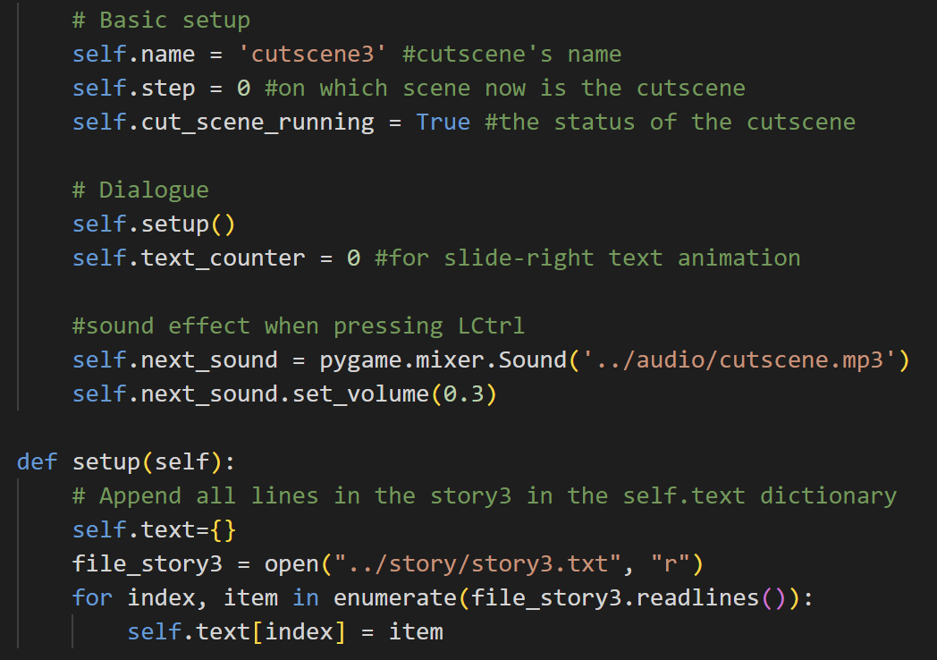



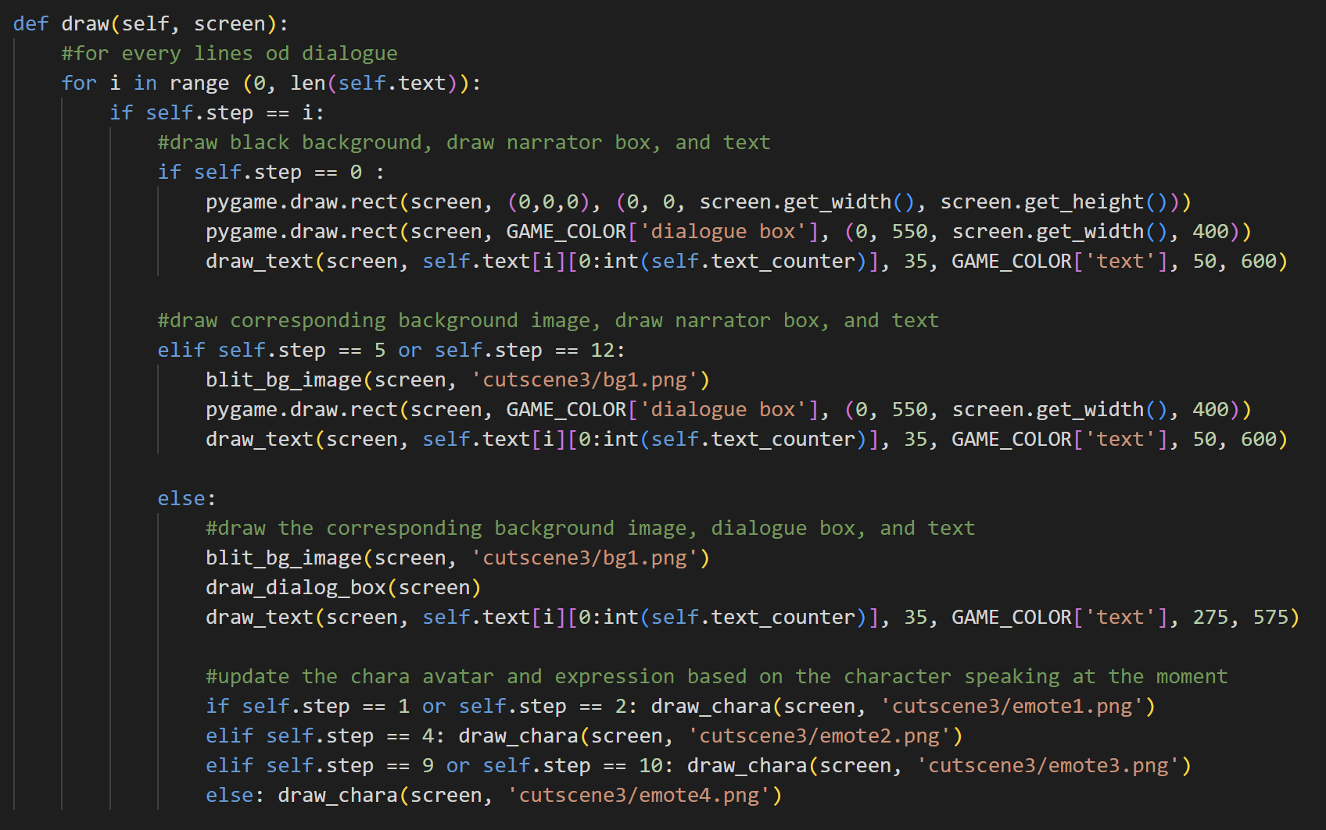

The draw method in CutSceneThree is more complex than the one in the previous cutscenes because here, there are several character icons, so it has to be more specified. Here, it blits a black background image in the first line as usual. After that, it will draw the narrator's box only on the sixth and thirteenth lines. Besides those, all of the rest are dialogue boxes. There are also different kinds of character icons for each specific line in the cutscene.

* Class CutSceneFour

The differences are also the same, which is the name and the story file in the setup method and also the draw method.

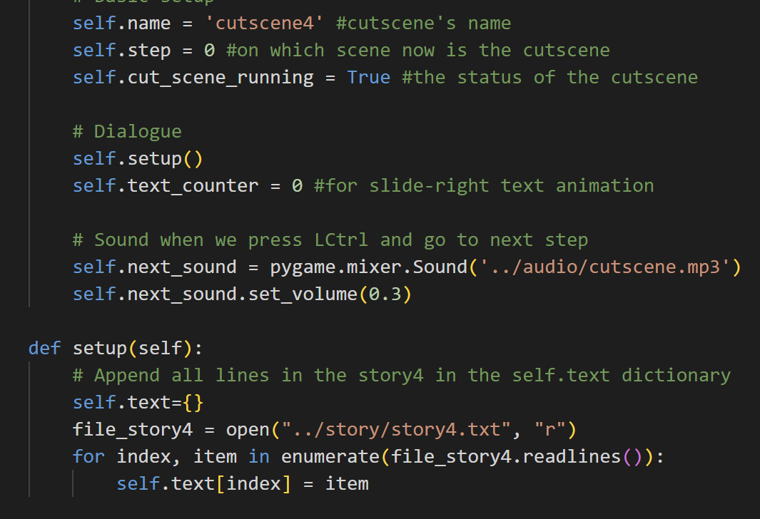

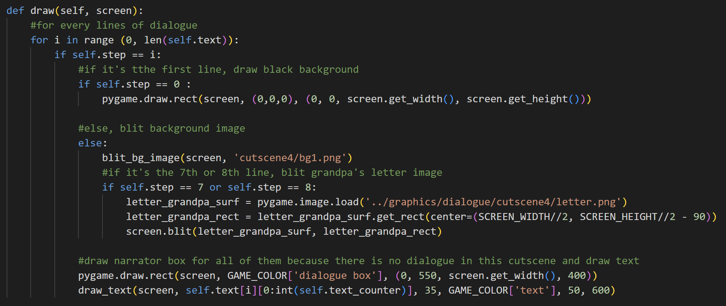

Here, in CutSceneFour, the draw method is more similar to the one in CutSceneOne because it only contains the narrator box. As usual, the first background image is still the black rect. The rest of the line has the picture in cutscene4/bg1.png as the background image. However, there is also a special image in the eighth and ninth lines of this cutscene, which is a letter image that will be blitted on top of the background image.

* Class CutSceneManager

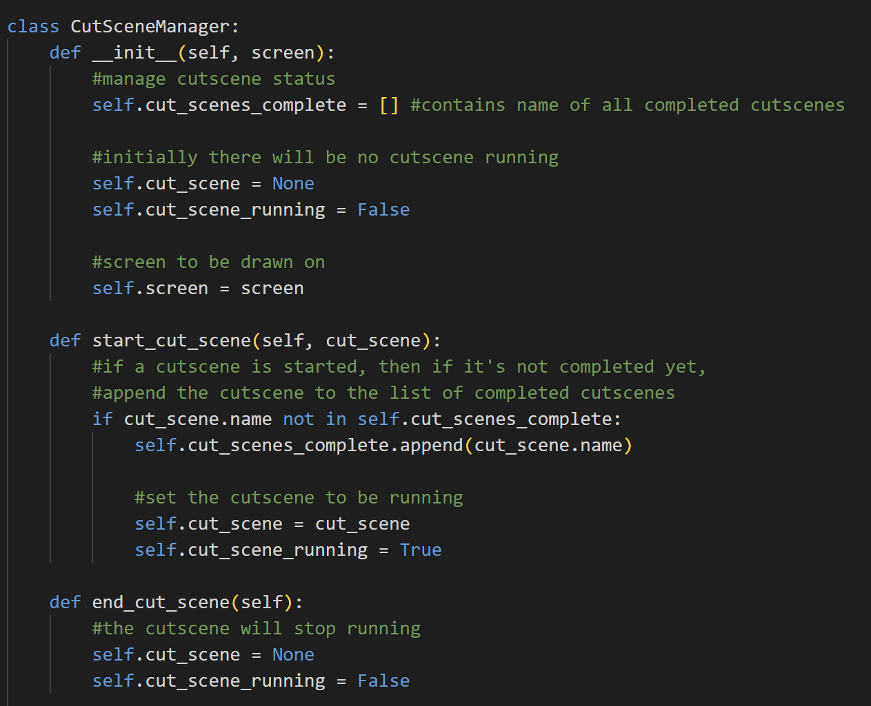

CutSceneManager is a class that helps to manage cutscenes. When we initialize an instance of this class, it will have the attribute: cut_scene_complete which is a list that contains all completed cutscenes’ names, cut_scene which will be None at the beginning because there is no cutscene object, the status of cut_scene_running is still False, and the screen.



The start_cut_scene method is used to append the cut_scene_name in the list of completed cutscenes if it’s not completed yet and the player starts the cutscene. When starting the cutscene, the cutscene object will run, and the status of the cut_scene_running will become True.



The end_cut_scene method is to set the cutscene back to None and the status of cut_scene_running back to False because the cutscene has ended.

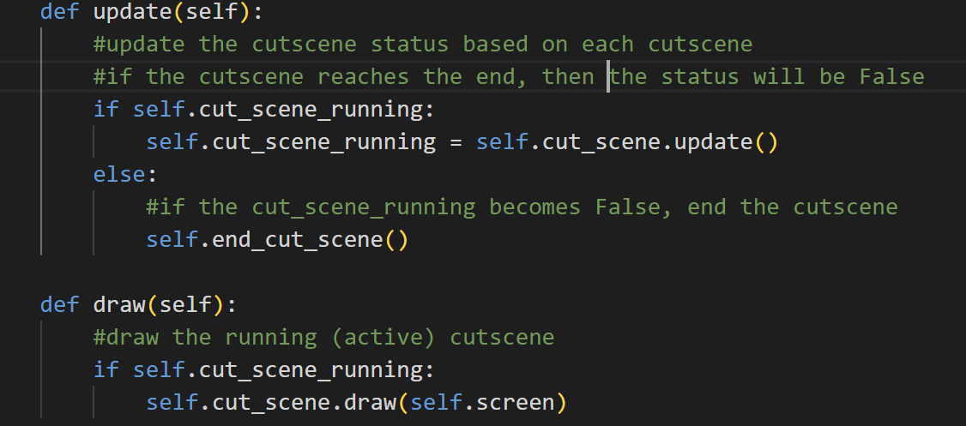

The update method is used to update the cutscene based on the update method in each cutscene. If the cutscene reaches the end of the dialogue line, then it will return False for cut_scene_running in the previous cutscene classes. If not, then it will be True. So, here it basically updates the cut_scene_running status periodically and if it becomes False, the cutscene manager will end the cutscene.



The draw method is used to call the draw method of each cutscene. So, if the cutscene is active or still running, then call the draw method of the running cutscenes, so that it can blit text, boxes, background image, etc.

1. **support.py**

This file contains functions and classes that are widely used in other files, especially the import_folder function. That’s why its name is “support.py” because it supports other files.

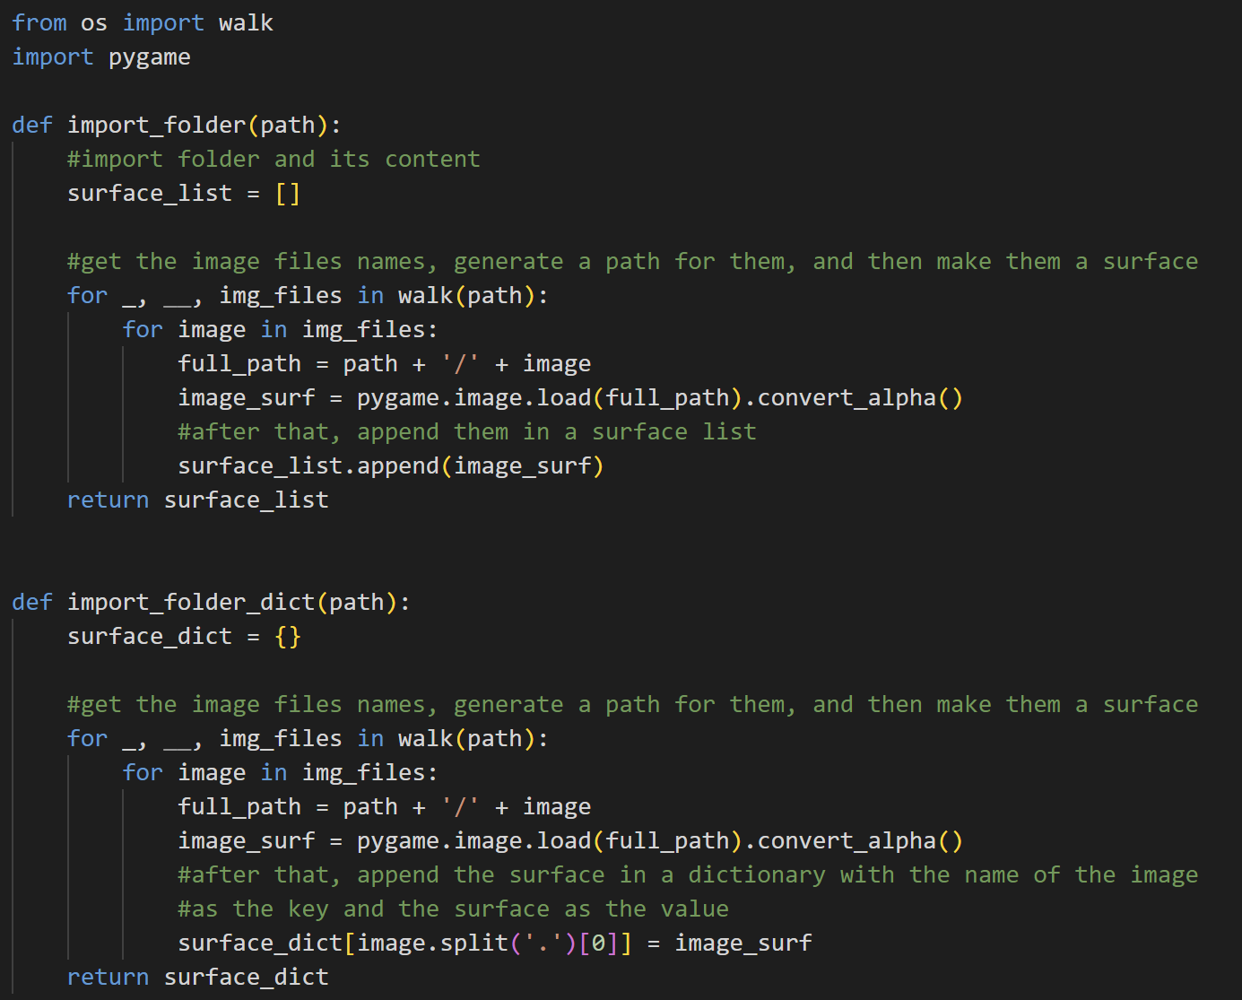

Import the walk function from the os module and import pygame.



The import_folder function is used to return a list of surfaces based on the path given in the parameter. First off, it will generate an empty surface list. After that, using the walk function, it will generate the name of the image files in the folder path. Then, it will load them as surface and append them to the surface list.



Next is the import_folder_dict function. This function is similar to the import_folder function but it returns a surface dictionary instead with the image file name as the key and the surface as the value. First, it will initialize a new surface dictionary. Then, it will walk the folder path and get the image file name. Then, it will generate a full path, so that it can load the image surface using that. After that, it will split the image name by ‘.’ so that the key will be only the image name, not containing the .png and the value will be the surface.

* Class Timer

The class Timer is used to let players have a more normal switching or doing some function experience. What this means is that for example, when we want to switch tools in this game, we have to press the ‘Q’ key. When we press it one time, pygame will not detect it as just one time, but it will detect it as a series of presses instead. So, the switching animation will be too fast and not comfortable for the player. So, it is important to have a timer, so that the player can only switch tools after some milliseconds.

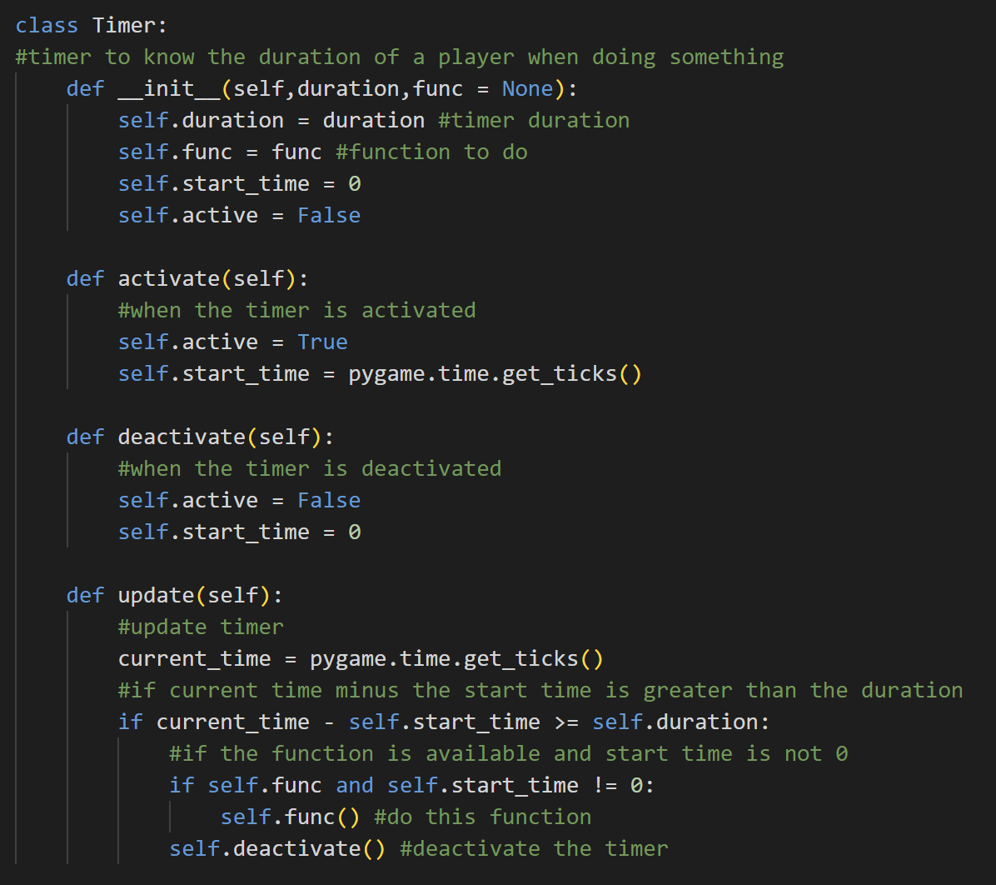

When we create an instance of the class Timer, there will be the duration of the timer, the function (that is by default None), the start time, and the status (active) of the timer which is by default False.



The activate method is used to activate the timer by setting the status of the active to True and the start_time of the timer to the current time when the timer is started.



On the contrary, the deactivate method is used to deactivate the timer by setting the status of the active back to False and the start_time back to 0.



The update method is used to get the current time. If the current time minus the start time is greater than the duration of the timer and if the function is None and the start time is not 0, the player can then do the function that they want. After that, the timer will deactivate. In other words, this Timer is something like ICD (Internal Cooldown).

* Class Button

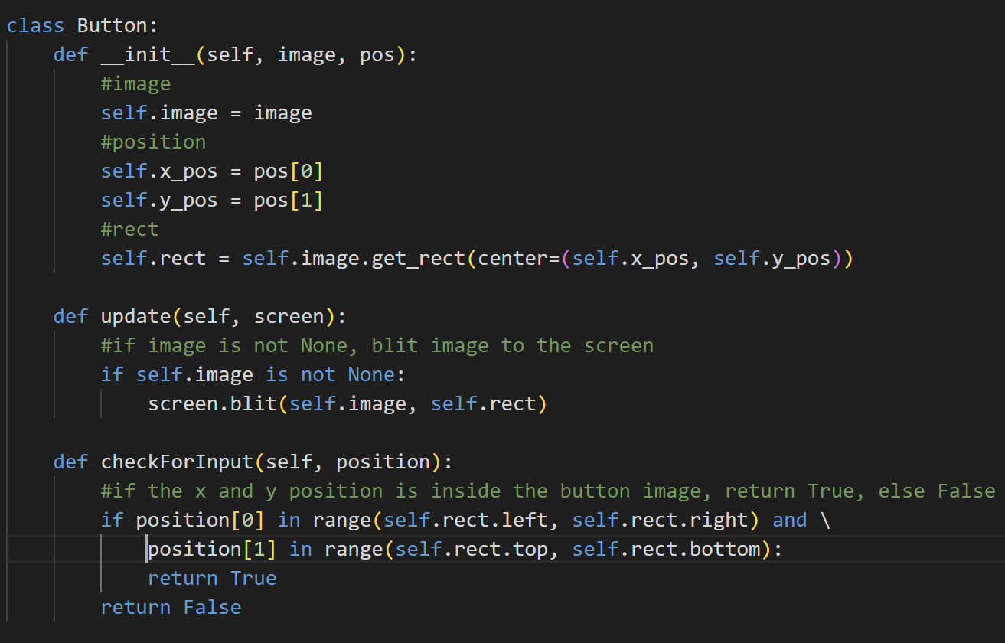

The Button class is used to create buttons. When creating an object of this class, it will have the attribute image, position, which is the x and y position, and also the rect. The rect itself is initialized by getting the image rect and setting it to center by the x and y positions.



The update method is used to blit the button image on the screen. If the image is not none, then blit the button image on the screen based on the image surface and its rect.



The checkForInput method is used to track the mouse position of the player. If the mouse’s x position is between the left and right of the rect and the y position between the top and bottom of the rect (the player mouse is inside the button), then return True. Otherwise, return False.

1. **sprites.py**

This file contains all the sprite classes that are used in this game.

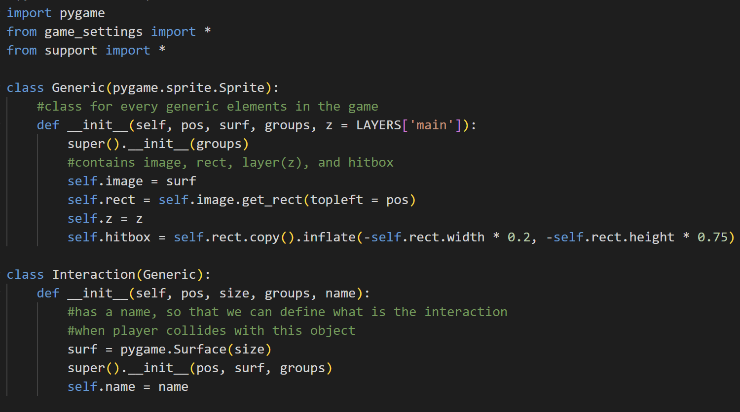

Import pygame, and from game_settings and support module import all.

* Class Generic



Generic is the standard class object for all the objects in this game as most of them will inherit from this class. Generic is also an inheritance of the pygame Sprite. Upon creating an object of the Generic class, the object will have the attribute of image (surface), the rect that is got by the image and position is set to top left to pos that is given, layers (which is by default the main layer because most of the objects are in this layer), and the hitbox. The hitbox is the copy of the rect and it is inflated to ensure a nicer collision detection effect.

* Class Interaction



Interaction is inherited from Generic and the surface is a non-visible pygame Surface because this sprite's main usage is to detect if a player collides with the object of this class or not. If yes, then do something based on the name of the object. That’s why the Interaction class has the name attribute.

* Class Water

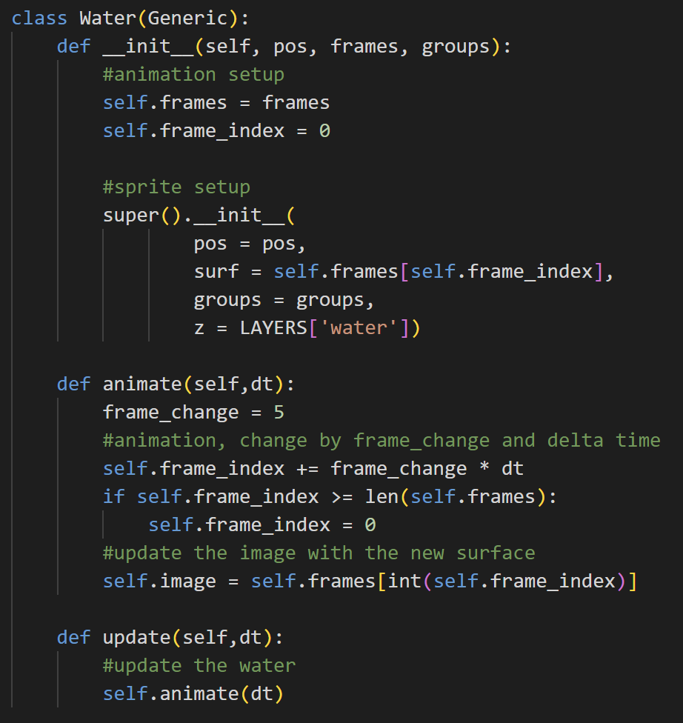

The Water class is also inherited from the Generic class. Upon initializing an object from the Water class, there will be additional attributes, which are the frames and the frames index. The reason is that, unlike ground, the water object will have animation.



The animate method is used to animate the water object based on the frame change and delta time. Delta time is used to ensure smooth animation across framerate. So, to animate this, the frame index will change based on the frame changing speed and the delta time, then if the frame index is greater or equal to the length of the list of the frames, then the frame index will go back to 0. The image surface will be updated periodically based on the frame index.

The update method basically updates the water by animating it.

* Class Particle

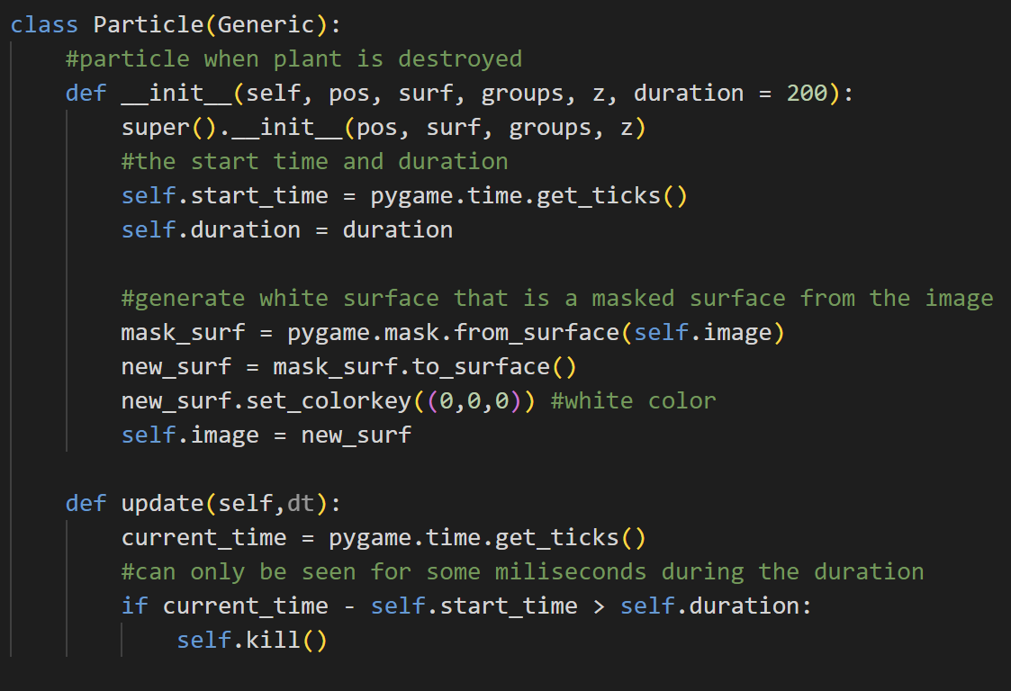

Particle is also inherited from Generic. An object of the Particle class is a white surface that has the same shape as the object and is normally seen when the player destroys the plant. The object from this class has the additional attributes of start time and duration. The image or the surface is the masked surface from the plant image and has a white colour.



The update method is used to update the particle. First off, it will get the current time. If the duration of the particle is lesser than the current time minus the start time, then the particle object will be killed. So, we can only see the object from the Particle class only for some milliseconds.

* Class Tree

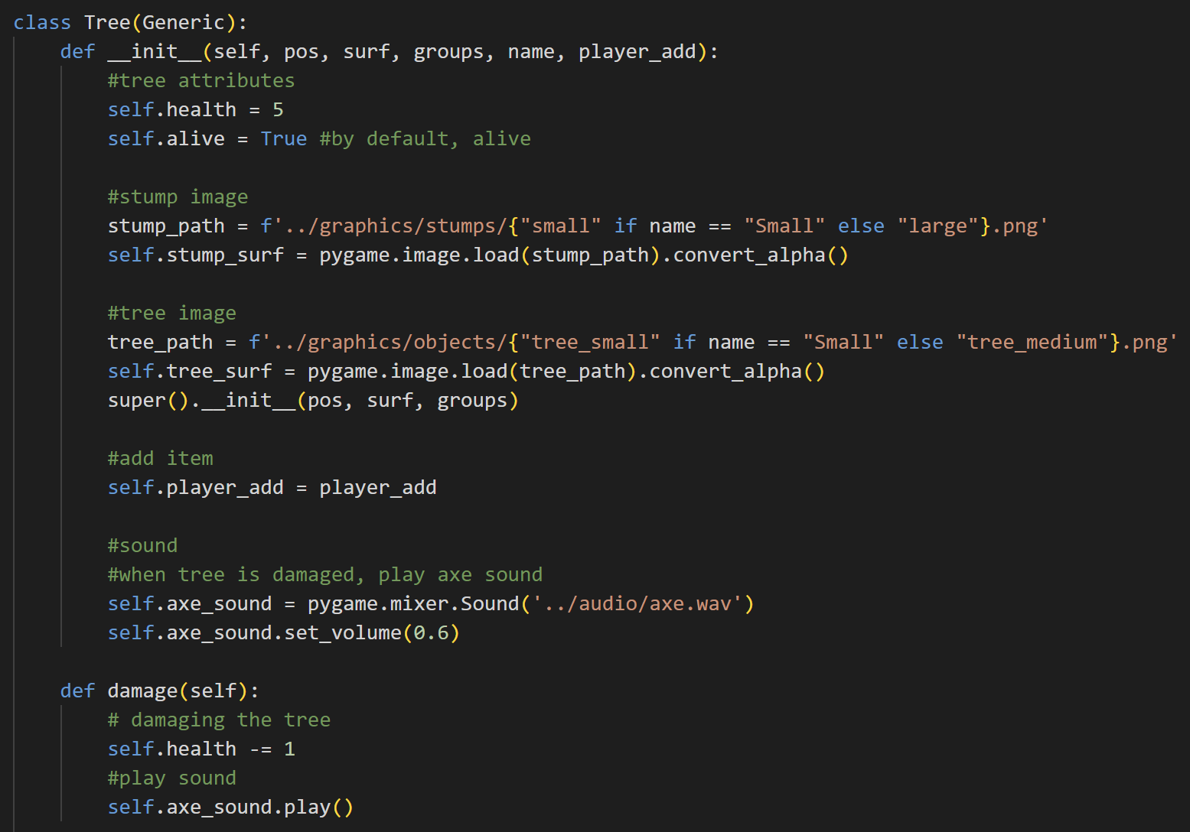

The Tree class is also inherited from the Generic class. An instance of this class has additional attributes, like health, the status of the tree (alive or not), the stump surface, the tree surface, the player add (to add the cut tree or wood to the inventory) and the axe_sound (which is played when the tree is damaged). The stump surface is different between small and large trees, and the tree surface is also the same. I also set the volume of the axe sound there to 0.3.



The damage method is called when the player damages a tree. If that’s the case, then it will decrease the tree’s health one by one and play the axe sound.

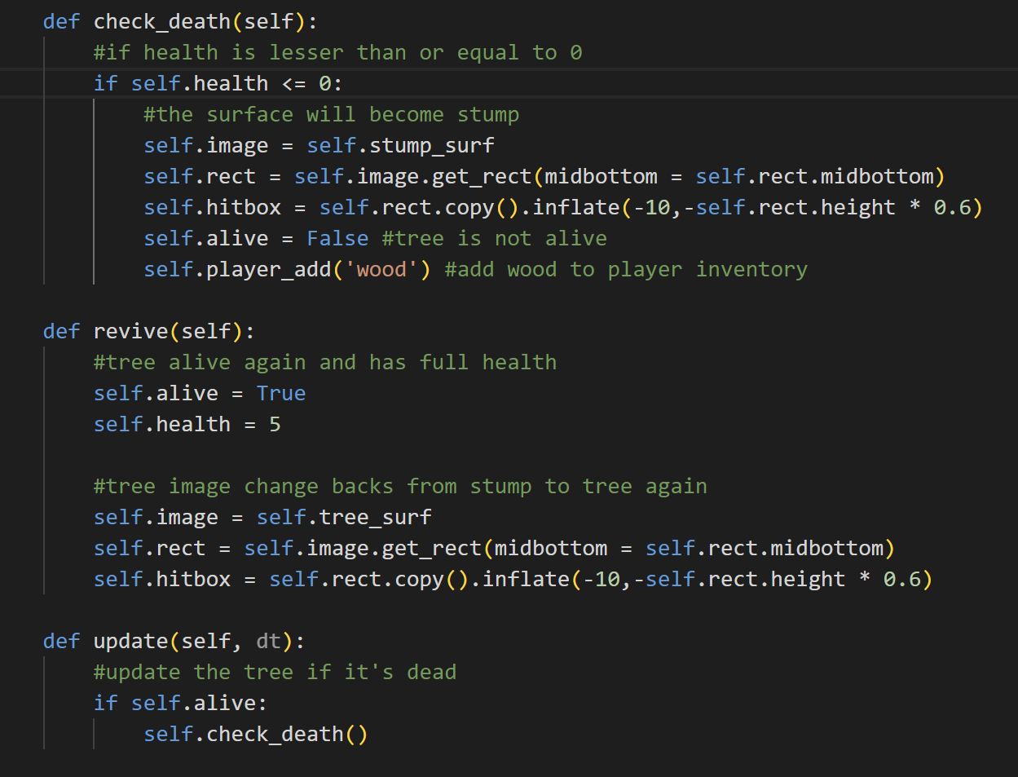

The check_death method is used to check if the tree is dead or not. If the tree is dead (the health is lesser or equal to 0), then the tree will become a stump. The surface will be changed to a stump surface and then get the rect and hitbox for the stump. The tree is dead, so the alive status of the tree also changes to False. It also adds 1 item of wood to the player’s inventory.



If we reset the day, the tree will be alive again and has full health (the alive status will back to True and the health becomes 5 again). The surface also changes from stump back to tree surface again, so we also have to get (update) the rect and hitbox of the new surface (the tree surface).



The update method is used to update the tree when the player is not sleeping. If the tree is still alive, check if it dies or not to constantly update them to stump if the player cuts them.

* Class Animal

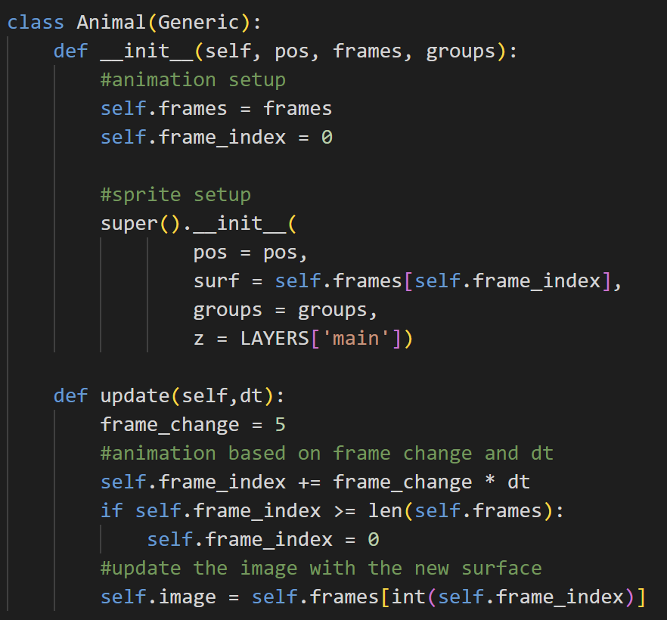

The Animal class is also inherited from the Generic class, but it has additional attributes, which are frames and frame_index (for animation). It is similar to the Water class, but it’s initialized on the ‘main’ layer.



The update method in the Animal class is used to update the frame for the animal (cow). So, the frame index will change (goes up) by adding itself with the frame change multiplied by the delta time. If the frame index is greater than the length of the frames, then the frame index goes back to 0. After that, update the image surface with the new surface from the frame index. The frame index has to be explicitly typed integer because it has the possibility to be a double and it will lead to an error.

1. **overlay.py**

This file contains the Overlay class that is used to handle the overlay picture of the tool and seed status on the bottom left of the screen.

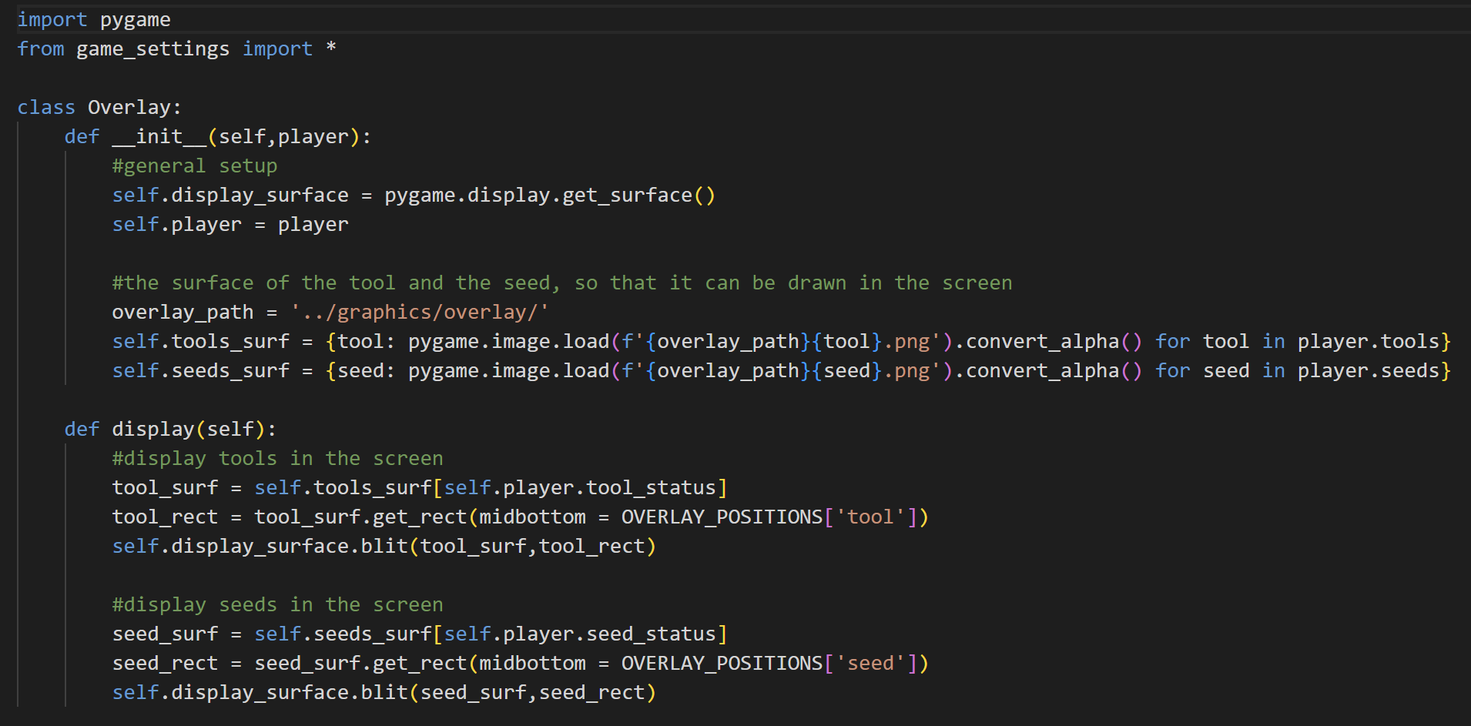

Import pygame and from game_settings import all constant variables.

* Class Overlay



When an object of the class Overlay is initialized, then it will have several attributes. The first one is the display_surface, which is obtained by getting the display surface using pygame. After that, the player. Then, there is an overlay_path which is the path to the image of the tools and seeds. Then, there are the attributes tools_surf and seeds_surf. The attribute tools_surf is a dictionary of the name of the tool as the key and the image surface of the corresponding tool as the value. Similar to tools_surf, seeds_surf is a dictionary of the name of the seed as the key and the image surface as the value.



The display method is used to display the tools and the seeds status overlay image on the screen. First off, it will get the tool surface based on the status of the tool that the player uses and the seed surface based on the seed that is currently active. After that, it will get the rect for the tool surface and the seed surface, and then blit both of them on the screen (display surface) with slightly different positions based on their rect positions.

1. **transition.py**

This file contains the class Transition which mainly handles the transition that is played when the player goes to sleep (reset the day).

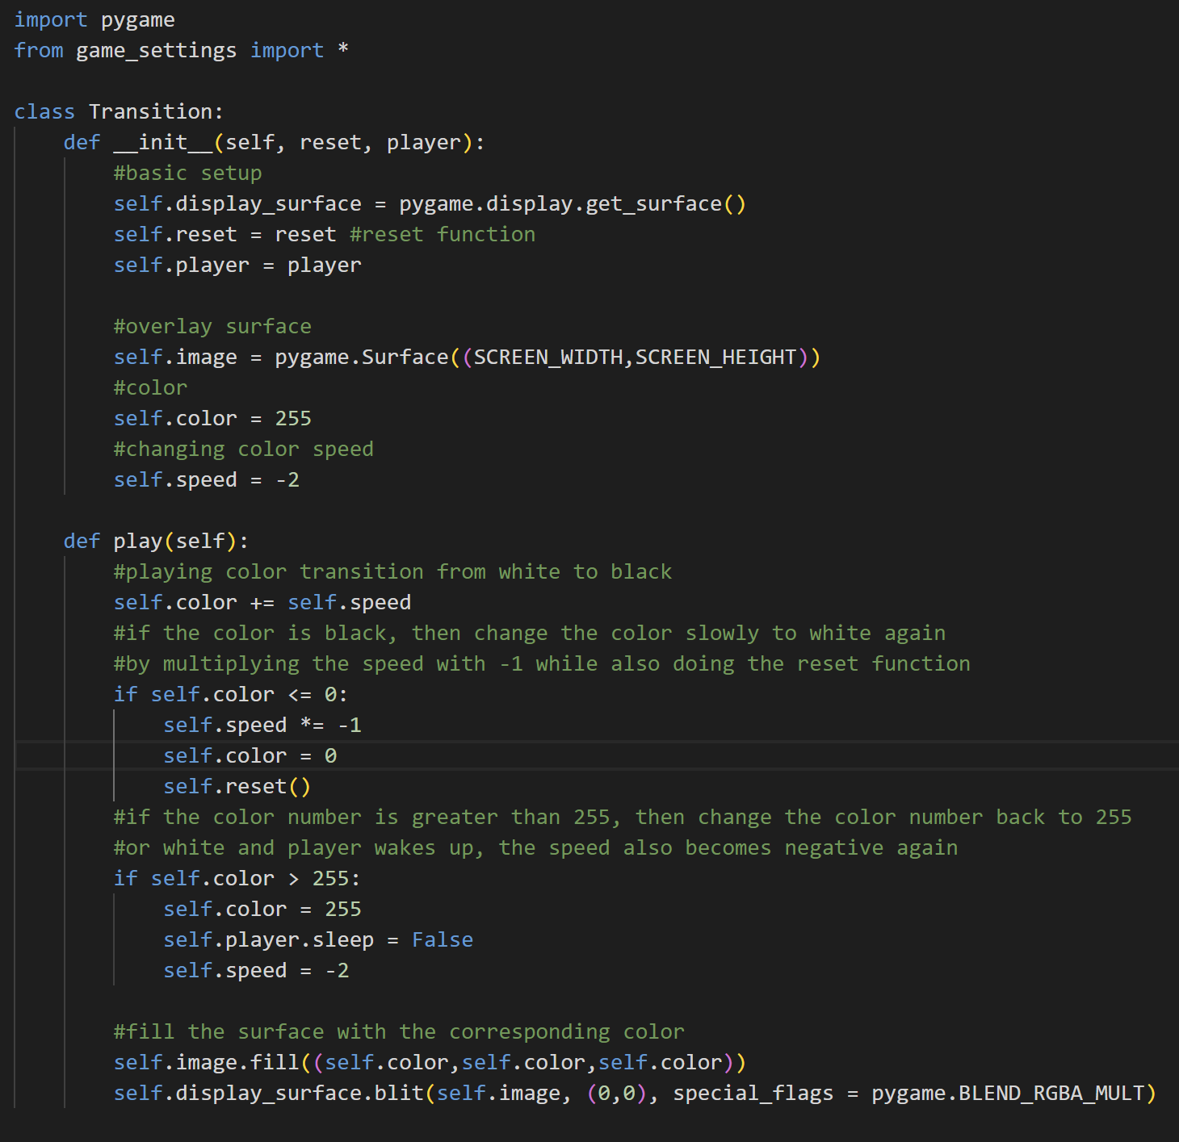

Import pygame and from game_settings import all of the constant variables.

* Class Transition



The object from the Transition class has several attributes, which are the display surface that is obtained by using pygame to get the display surface, the reset function, the player, the overlay surface (image), the colour (initial), and the colour change speed.



The play method is to play the colour transition. First of all, the overlay surface is still invisible (doesn’t have any colour when we initialize it). Then, the play method will increase the colour number by adding it with the colour-changing speed. After that, if the colour number is 0 or lesser now, set the colour number to 0, multiply the speed by -1 to add 0 into 255 again and also do the reset function.

If the color number is now 255 again, then the player will wake up and the speed and colour number will be changed to the initial value. The surface will be filled periodically based on the colour number. The surface will also be blitted with the special flag multiply (kind of giving a shade layer on top of the surface). So, basically what this method does is to change the shade layer from white into black and then white again.

1. **sky.py**

This file contains the class Sky for day-night transition, class Rain and class Drop for the weather system (if it’s raining).

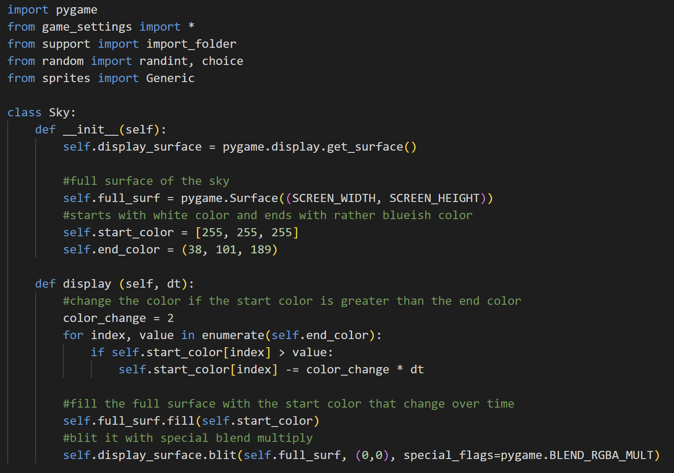

Import pygame and from game_settings import all, from support import import_folder, from random import randint and choice, and from sprites import Generic.

* Class Sky



When initializing an instance of this class, there will be several attributes. The display surface attribute is obtained by getting the display surface with pygame. Then, the full surface is the shade surface on top of the screen, so its size has to be the same as the screen width and screen height. After that, there are the attributes start colour which is white and the end colour which is dark blue. The start colour is a list because it will change over time.



The display method is used to change the sky colour. The colour-changing speed is 2. For every item in the end colour tuple, if the start colour’s item that has the same index as the end colour’s item is still greater than the end colour’s item, then change the start colour’s item based on the colour change speed and delta time. After that, it will fill the still no colour full surface with the colour of the start colour that changes over time. It is also blitted in multiply.

* Class Drop

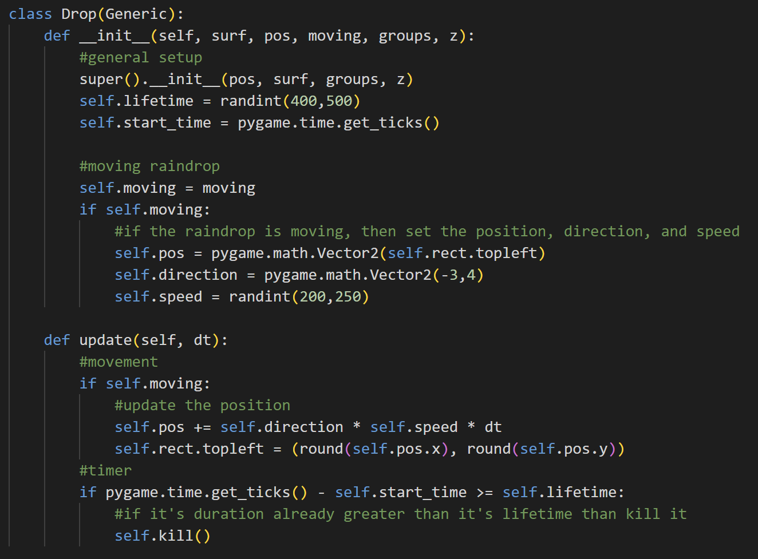

The Drop class is inherited from the Generic class, so it has the attributes of the Generic class. It also has additional attributes, like lifetime, start time, and moving. The Drop class will also be used to create the rain floor beside the raindrop, so if it’s moving (it’s a raindrop), then it has position, direction, and speed. The position and direction are two-dimensional vectors, while the speed is randomized between 200 and 250.

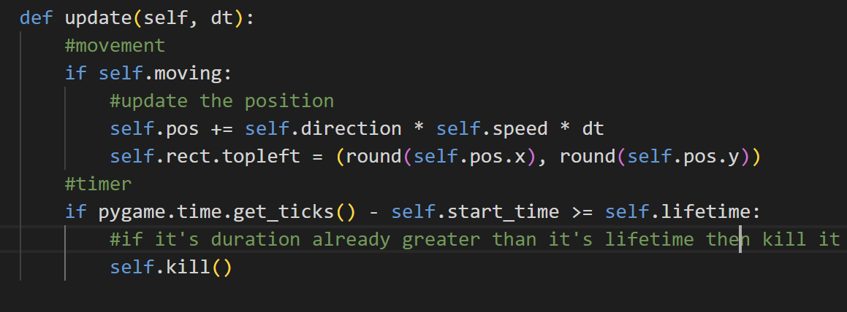

The update method is used to update the raindrops and rain floors. If it is moving (raindrop), then it will update the position of the raindrop by adding its position with the direction multiplied by the speed and delta time. Then, it sets the rect based on the position that is rounded (so, it will be not in double). Next, there is also a timer regardless it is moving or not. If the current time minus the start time is greater or equal to the lifetime of the Drop object, then kill it.

* Class Rain

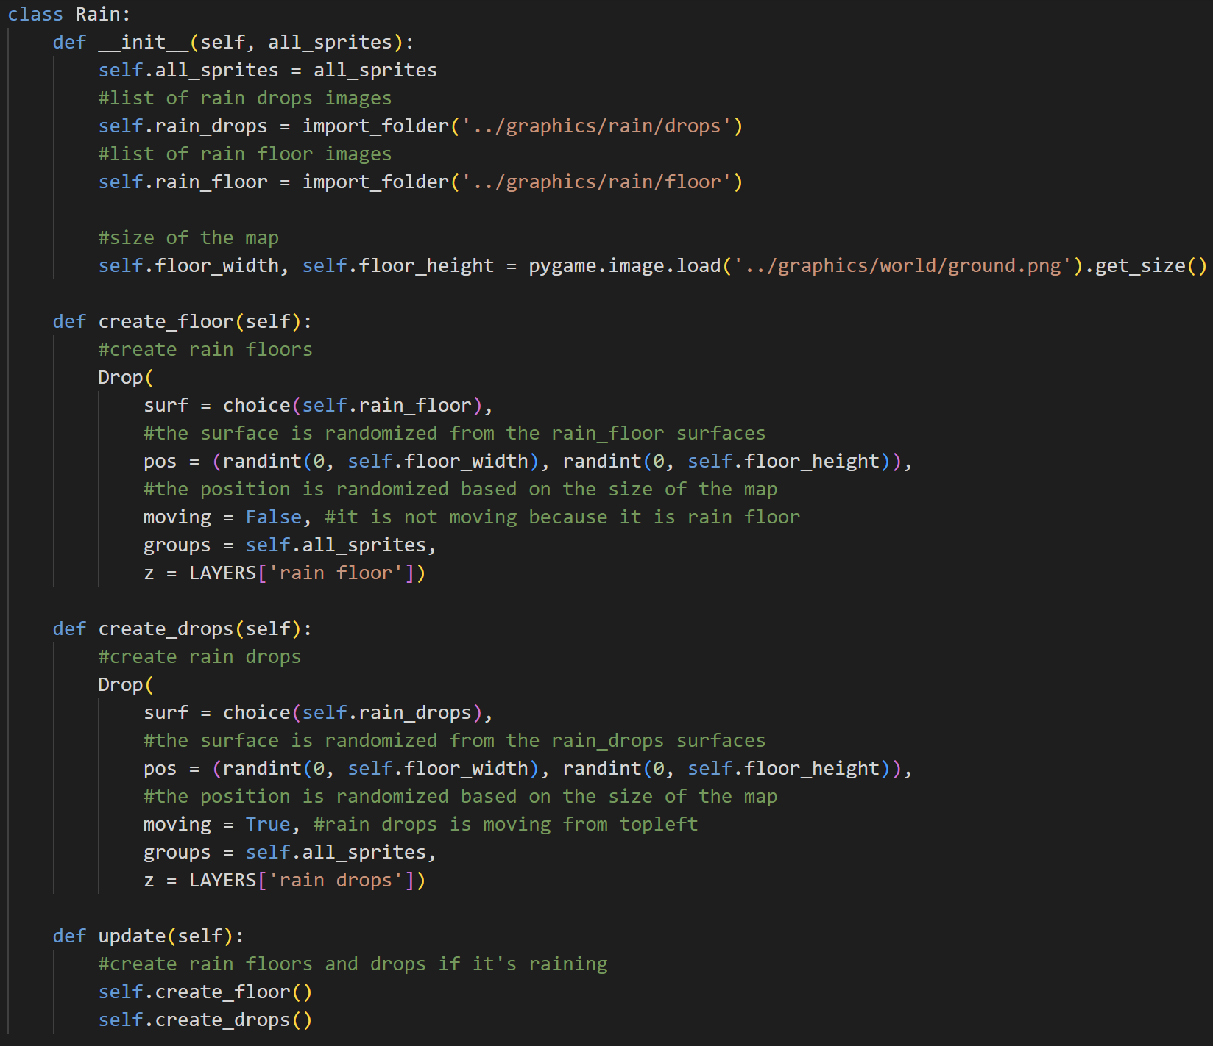

When we create an object of the class Rain, it will have the attributes all_sprites, rain_drops (list of raindrop image surfaces), rain_floor (list of rainfloor image surfaces), and floor width and floor height (the width and height of the map).



The create_floor method is used to create a Drop object with the surface being randomized between all the choices inside the rain floor list, the position is randomized between 0 until the width and height of our map, moving is False because it is rain floor, the group is all sprites, and the layer is rain floor.



The create_drops method is used to create a Drop object with the surface being randomized between all the choices inside the raindrops list, the position is randomized between 0 until the width and height of our map, moving is True because raindrops move from top to bottom, group is all sprites, and the layer is rain drops.



If it’s raining, the updated method will create rain floors and raindrops by calling the create_floor and create_drops methods.

1. **overlay_menu.py**

This file contains the class for the overlay menus in this game, which is the Overlay_Menu class for the help menu and the Inventory class for the inventory.

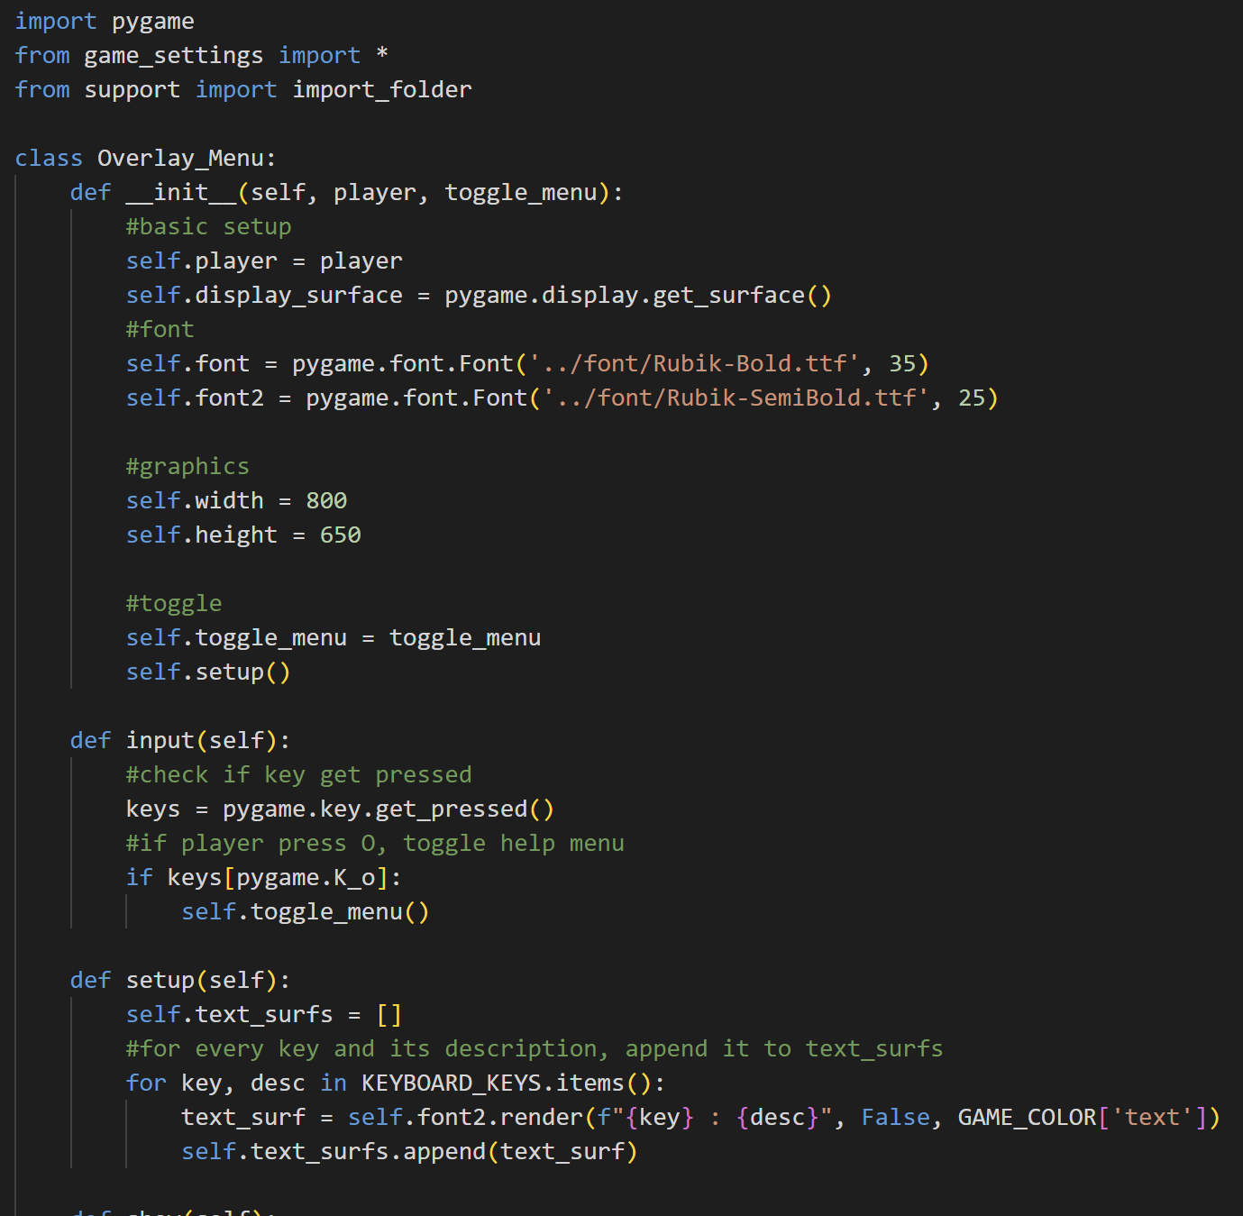

Import pygame, from game_settings import all constants, and from support import import_folder function.

* Class Overlay_Menu



When initializing an object from this class, the object will have some attributes. The attributes are the player, the display surface that is obtained by using pygame, the font (font is for the header and font2 is for the text), the width and height of the menu, and the toggle function. It will also call the setup method.



The input method will check if there is any key that gets pressed. If the help menu is active and the player presses the ‘O’ key, then toggle or close the help menu.



The setup method is used to initialize the text_surfs list that contains all the text surfaces that will be blitted on the screen later on. So, it will first initialize an empty list and, then for every key and its description in the keyboard shortcut dictionary, it will render font2 with the key and its description as the text surface. After that, the text_surfs list will append the text surface.

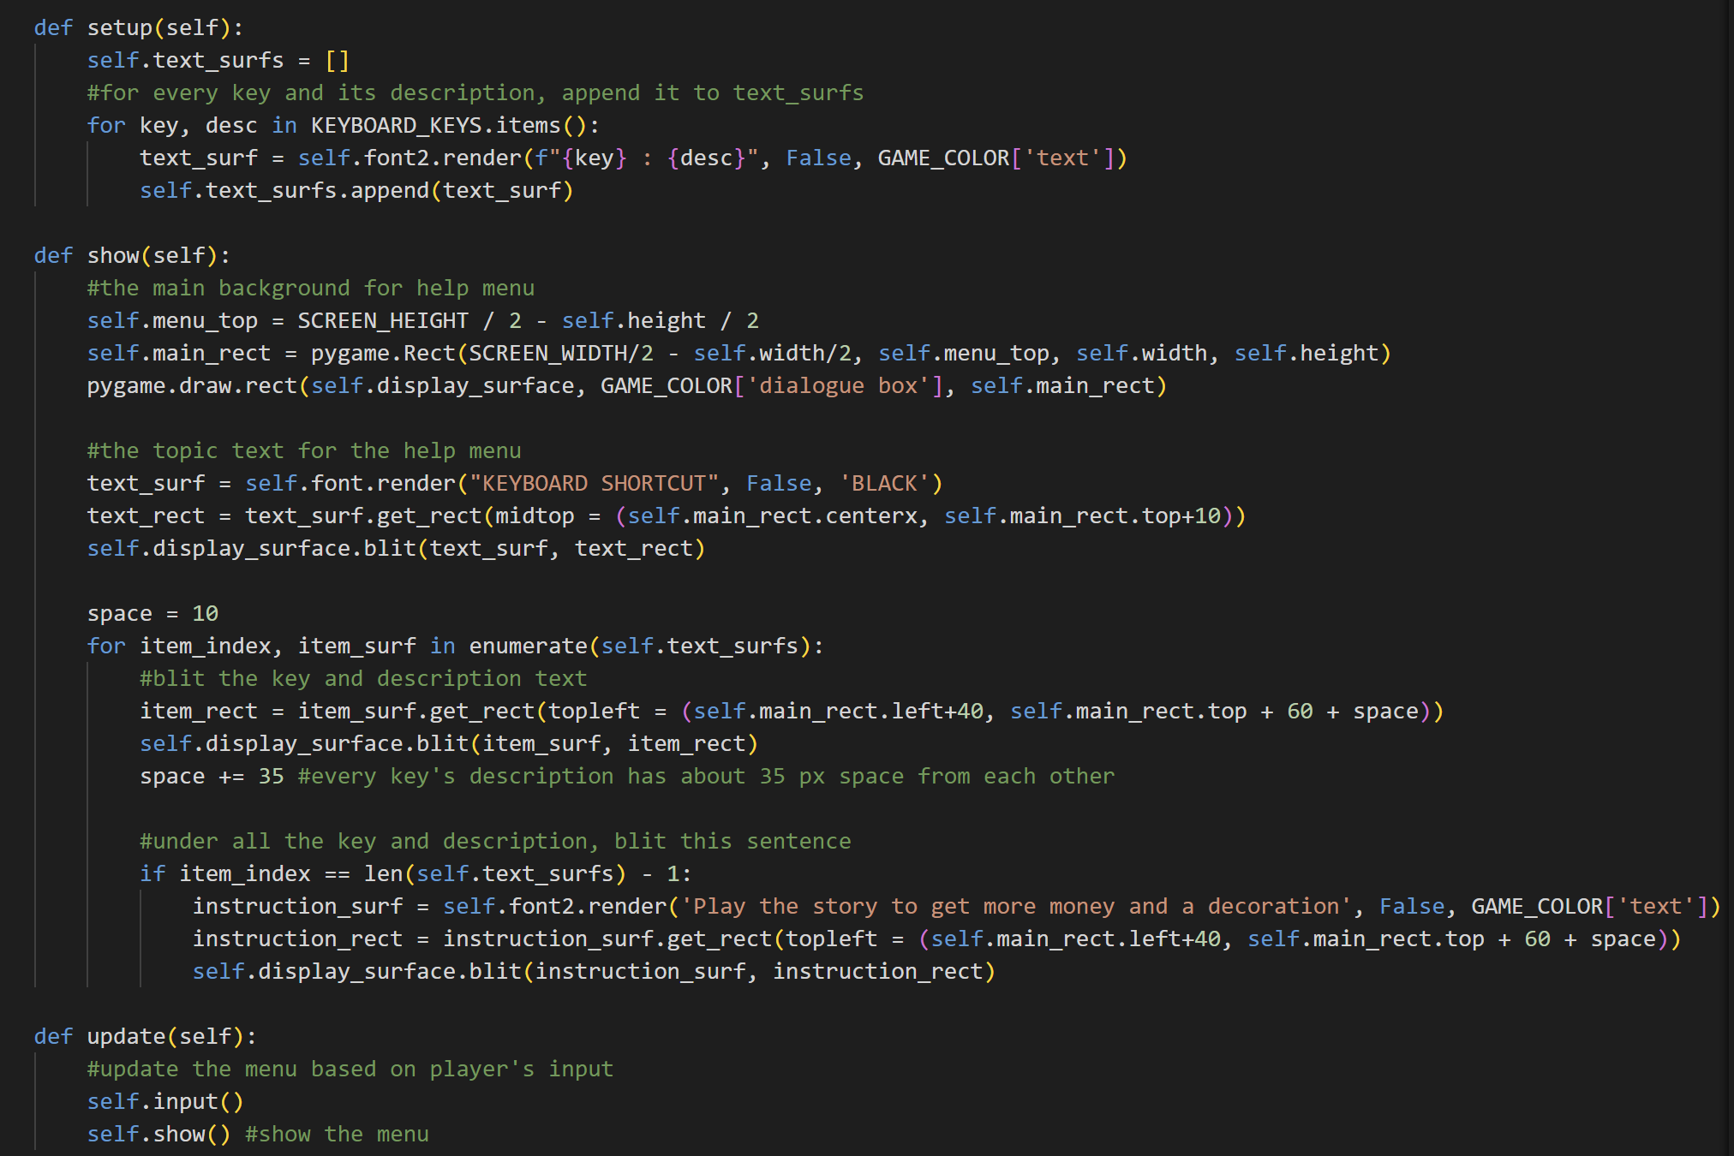

The show method is used to show the menu and the text. First off, it will get the top of the menu position and draw the main rect based on the positions. The main rect will be drawn on the display surface with the colour of light brown as the menu’s background. Next, it will render the text “KEYBOARD SHORTCUT” by using self.font into a surface and then get the rect. After that, it will also blit it on the screen.

After that, for every item in the text_surfs list, blit the key and description text into the display surface. The y position of each text is affected by the space which is the space for each line of text. The space will be added by 35 every iteration so that every line has about 35px for the vertical space.

After all the keys and descriptions are blitted or the item is already the last item, blit the instruction surface on the lowermost by first rendering the text using font2 and getting the rect.



The update method will update the help menu based on the player input (toggle) and also show the content of the menu.

* Class Inventory

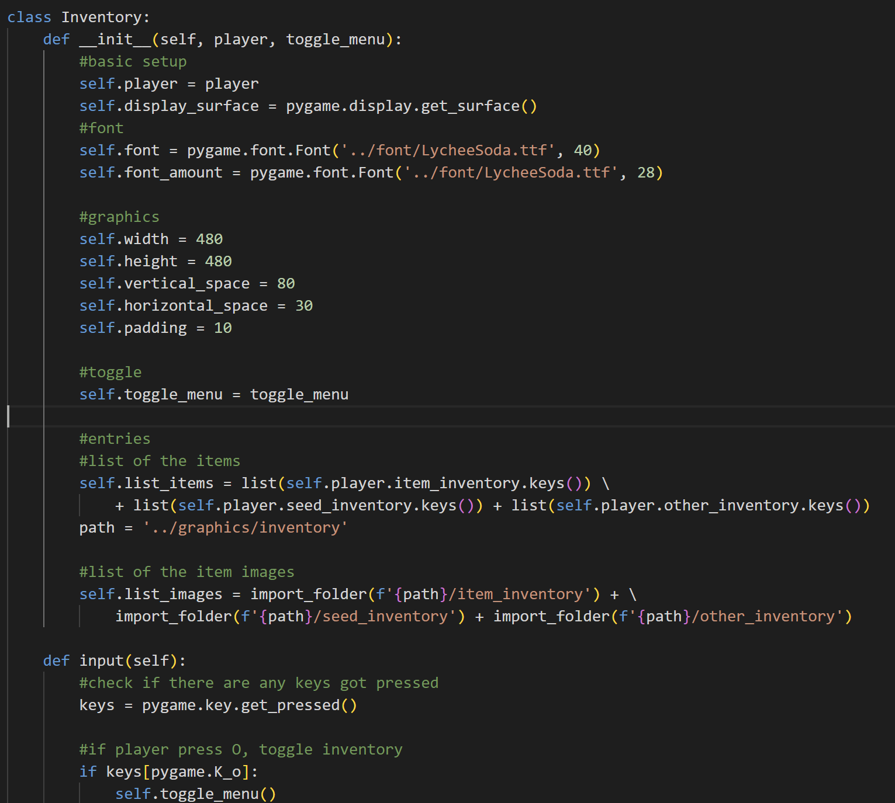

Class Inventory is used to handle the inventory in this game. The object of this class has several attributes: the display surface that can be obtained by using pygame, the player, the font (for header text), the font_amount (for amount text), the width, height, vertical space, and horizontal space, padding, toggle function, list of the items names, and list of the items image surfaces. The image surfaces list is generated by using the import_folder function based on the path given there.



The input method is used to check if the player presses any key or not. If inventory is active and the player presses the O key, then close the inventory.

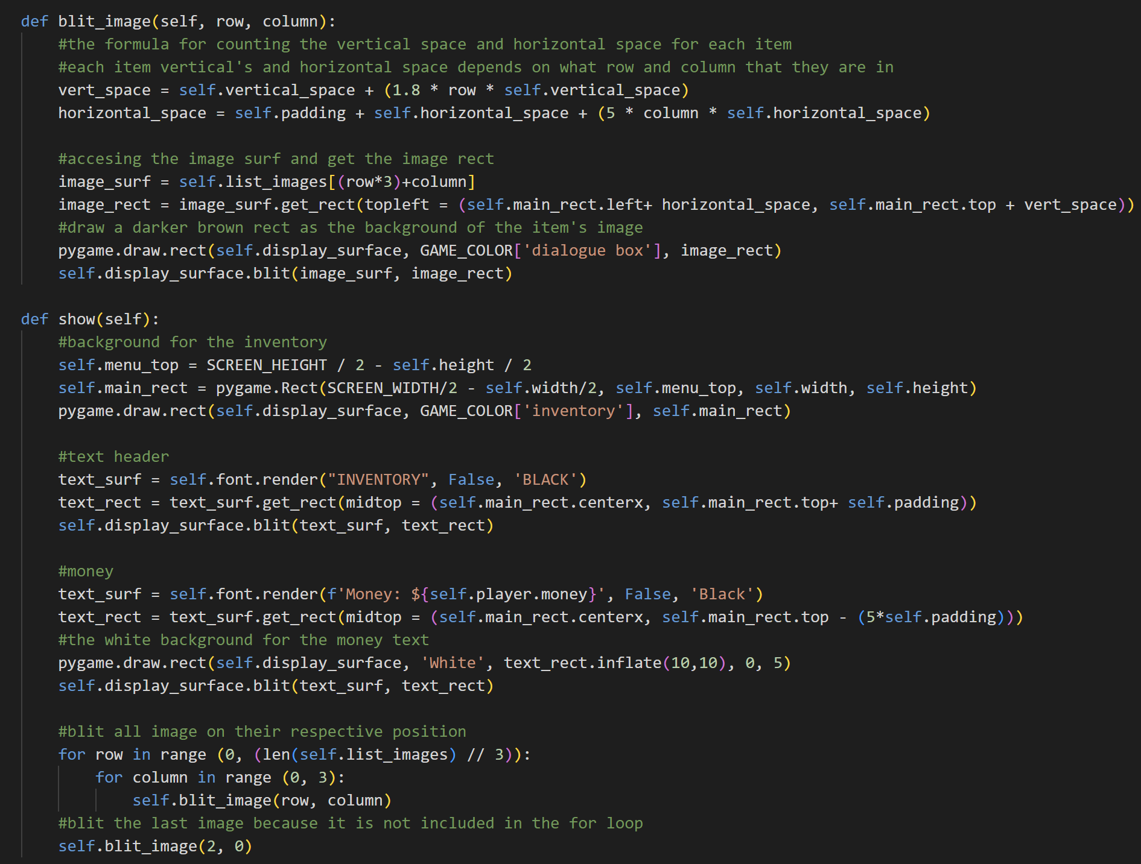

The blit_image will first calculate the vertical space and horizontal space of the item based on which row and column it is in. After that, it will get the image surface from the list_images. The index will be row times 3 added by column. The reason is that every row has a maximum of three items. After that, it will get the rect, blit the image, and draw a dark brown rect as the item’s image background.



The show method is used to show the content of the inventory. It will first calculate the top of the menu and draw the main rect (the background of the menu) on the screen. After that, it will render the text header, get its rect, and blit it on the screen. Then, it will also render the player’s money text above the menu and blit it. The money text also has a white surface as the background. The white surface is generated by using the rect of the text and it is inflated.

It will also blit all the images on their respective row and column. For every row in range 2 (because 7//3=2), for columns in range (0, 3), blit image on their row and column. The reason why the column is in the range 0 until 3 is because 1 row has a maximum of 3 items. So, this code has a little flaw, where it will only blit the first 6 items. So, we have to blit the seventh item after that.

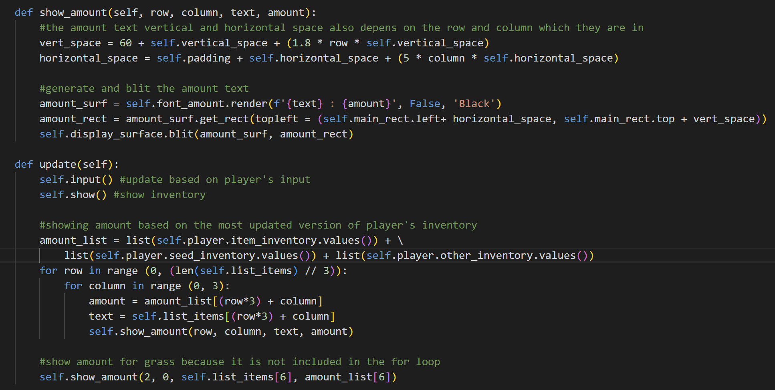

The show_amount method is used to show the amount of the item. It will first calculate the vertical and horizontal space too based on the row and column in which the item is in. After that, it will render the item’s name and its amount on the surface, get its rect, and blit it on the display surface.



The update method is used to update the menu based on the player input and show the content of the menu. The amount of the item in the inventory is subject to change, so it has to be included in the update method too. So, first, it will periodically update the amount_list based on the values of the player’s inventory. After that, in a similar way to the blit image, it will blit the first 6 items’ amounts on the inventory menu. So, we have to type manually for the seventh item which is the grass because it is not included yet in the loop.

1. **merchant_menu.py**

This file contains the Menu class to handle the shop menu in this game.

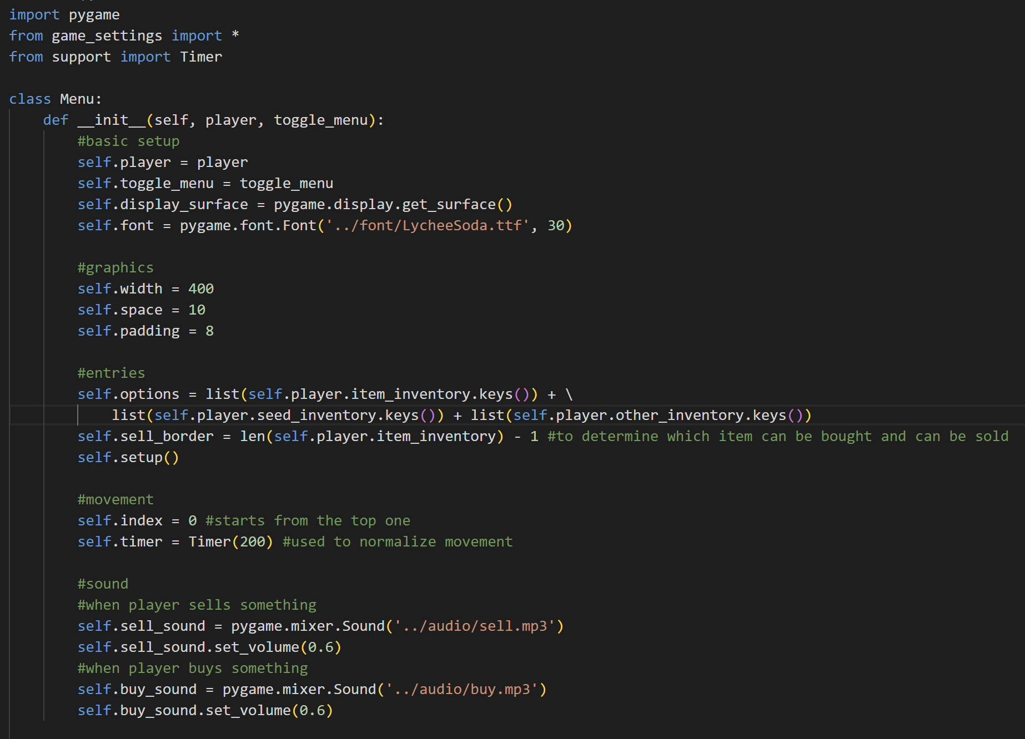

Import pygame, from game_settings, import all constants, and from support import Timer.

* Class Menu



When initializing an object from this class, it will have several attributes from the player, toggle function, the display surface (obtained using pygame), font, width, space, padding, options (the keys or the name of the items in the player’s inventory), sell_border (to determine which item can be bought and which item can be sold), the index, timer, sell_sound, and buy_sound. The index and the timer are used for movement when navigating to buy or sell an item. By default, the player will start on index 0 or the top of all of the entries. The timer is used to normalize the navigation so that when we press the arrow button, it will not loop that fast. The sell sound is played when the player sells something and the buy sound is when the player buys something. Here, we also call the setup function.

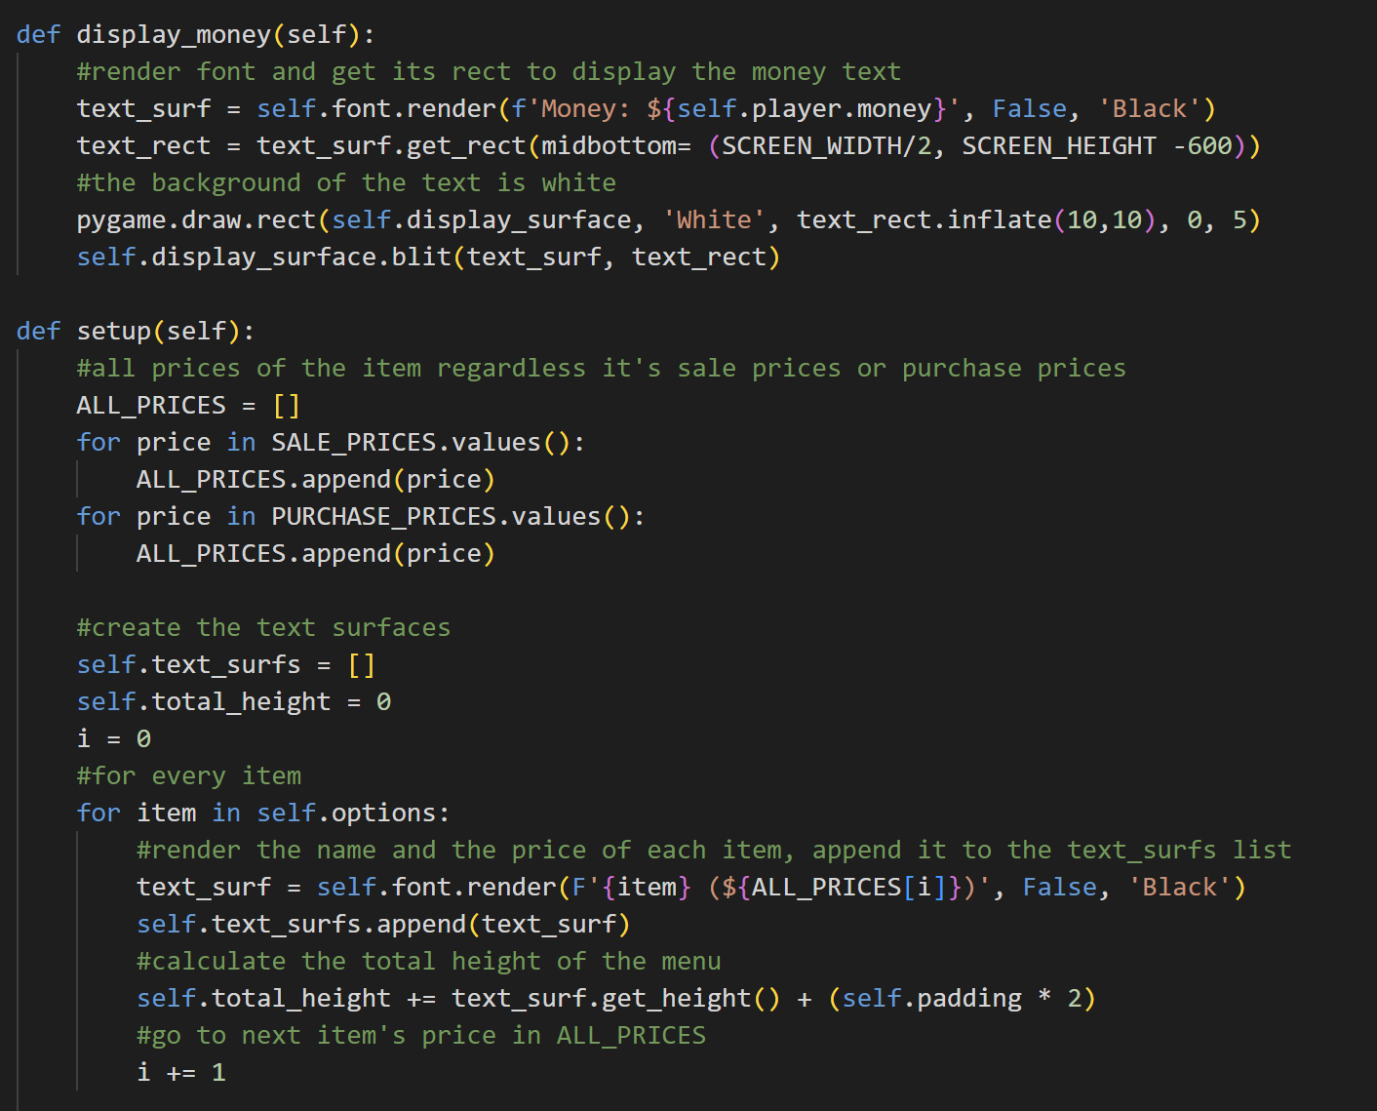

The display_money method is used to display the player’s money. Same as the inventory, it will first render the money text into a surface, get its rect and blit it on the screen. It will also draw a white rect to become the background of the money text. The rect is obtained by inflating the text rect.

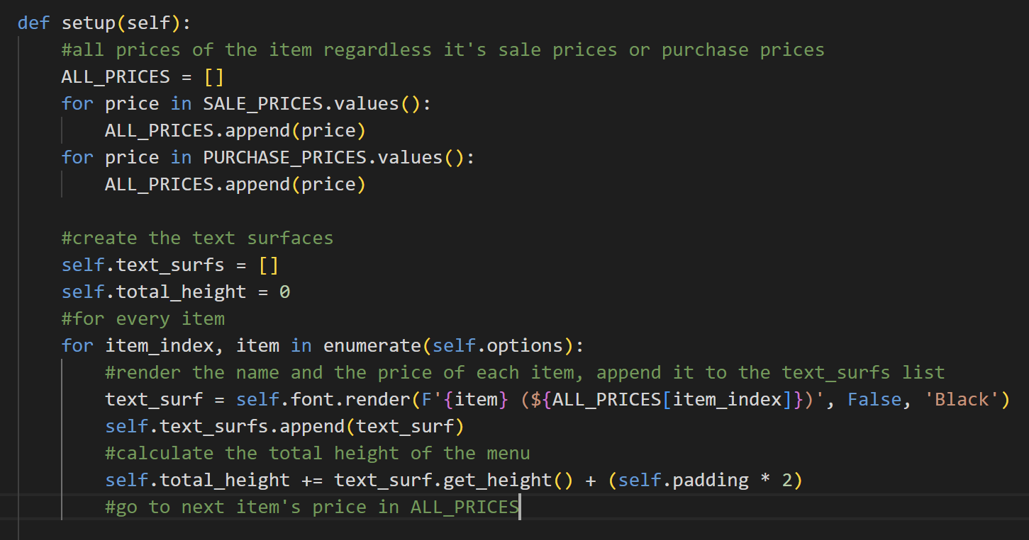

The setup method will first append all the sale and purchase prices in a list. After that, it will initialize an empty list for the text surfaces. It will also initialize the total height to 0. The item index is used to help assess the price of each item based on its index. So, it will render the name and the price of each item and append it to the text surfs list, then it will calculate the total height based on the text surfaces’ height.

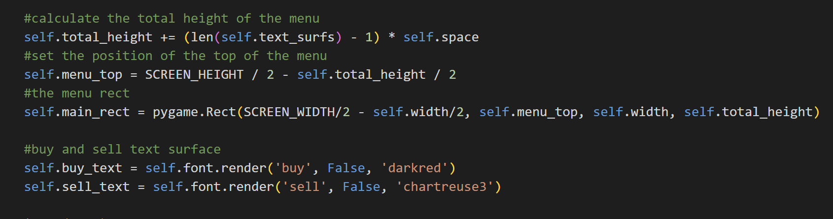

Then, it will calculate the total height by adding it to the length of the text surfaces multiplied by the space. The reason is that the shop menu, unlike the inventory and help menu, doesn’t have a big rect as the background image, but instead, every entry has its own rect. It will also calculate the top of the menu and generate a main rect (but doesn’t blit it). There will be also the text ‘buy’ and ‘sell’ in the shop menu for every entry. The ‘buy’ text will be in dark red and the ‘sell’ text colour will be in green.

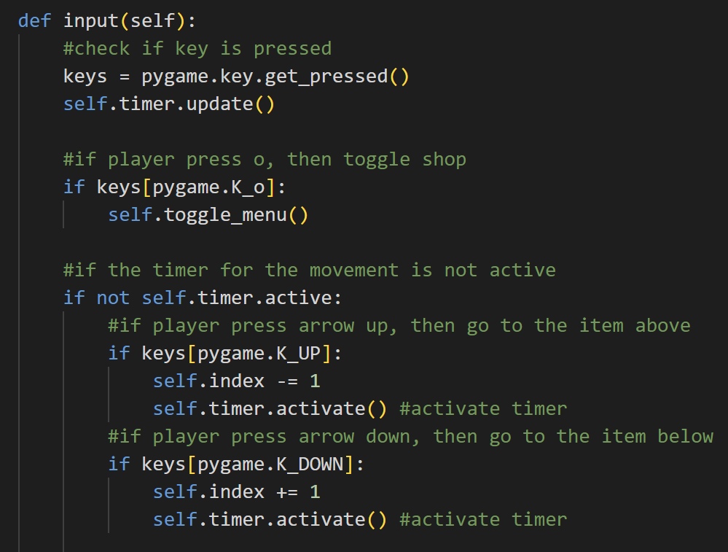

The input method will first check if there are any pressed keys and update the timer. If the player presses O, then close the shop menu. If the timer movement is not active, the player can navigate up or down. If they start to navigate up or down, the timer will activate. If they navigate up, then the index will be minus by 1, else if they navigate down, then the index will be added by 1.

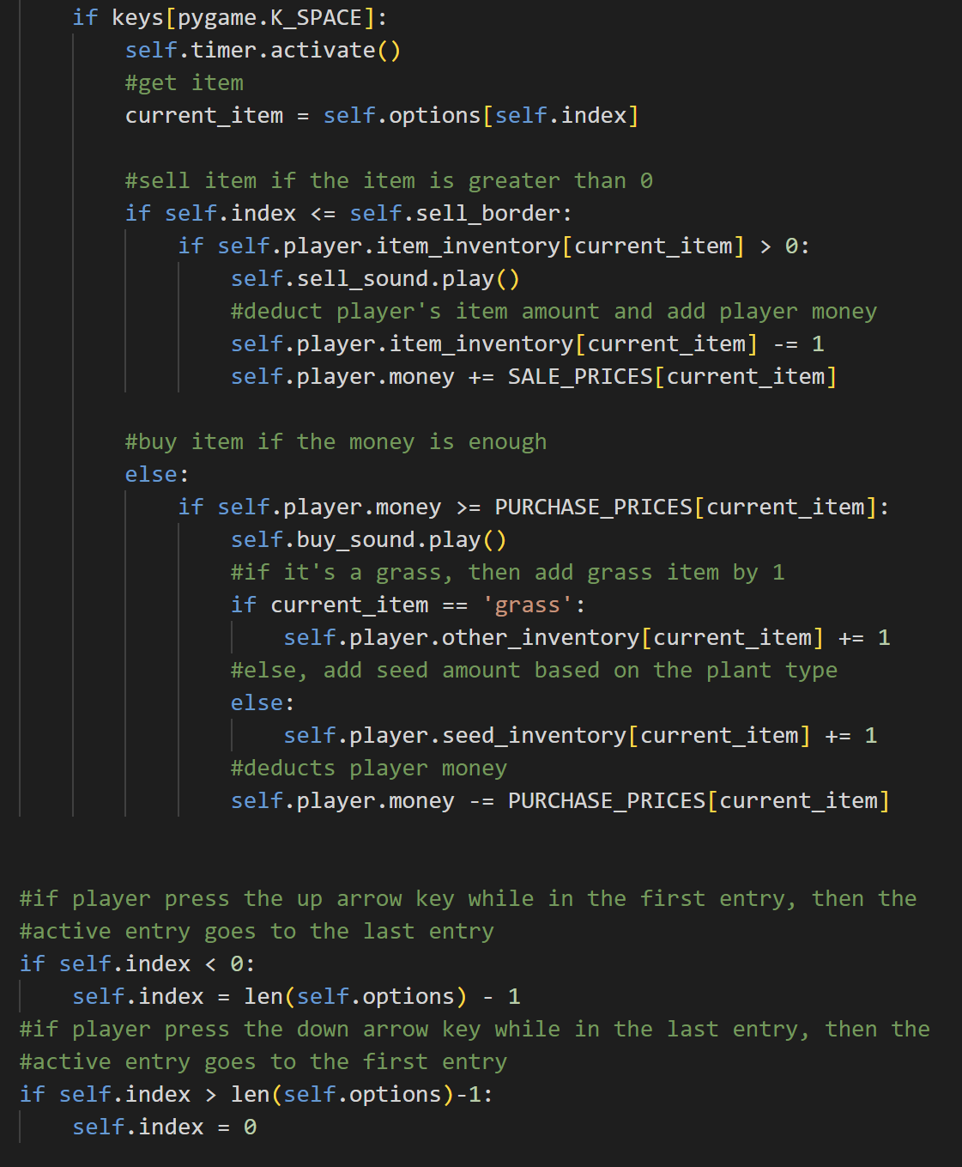

If the player presses space, then activate the timer too and get the current item based on the index (the position player is right now). If the index is lesser than the sell bolder, then it means that it’s still in the item_inventory. The item in the item_inventory can be sold. If the player’s current item is greater than 0, then the player can sell the item. Sell sound will be played, the item will be deducted from the player’s inventory, and the player’s money will be added based on the sale price of the current item.



Otherwise, if the current item is not in the item inventory, it means that it can be bought. If the player’s money is greater or equal to the purchase price of the current item, then play the buy sound and deduct the player’s money based on the purchase price of the current item. If the current item is grass, then add it to the other inventory because grass is in the other inventory. Otherwise, it will be added to the seed inventory.



If the player presses the arrow key up when they are in the first entry (index becomes lesser than 0), then go to the last entry (index will be the length of the list minus 1). If the player presses the down arrow key although they are in the last entry (index becomes greater than the length of the list minus 1), then set the index back to 0 (go to the first entry).

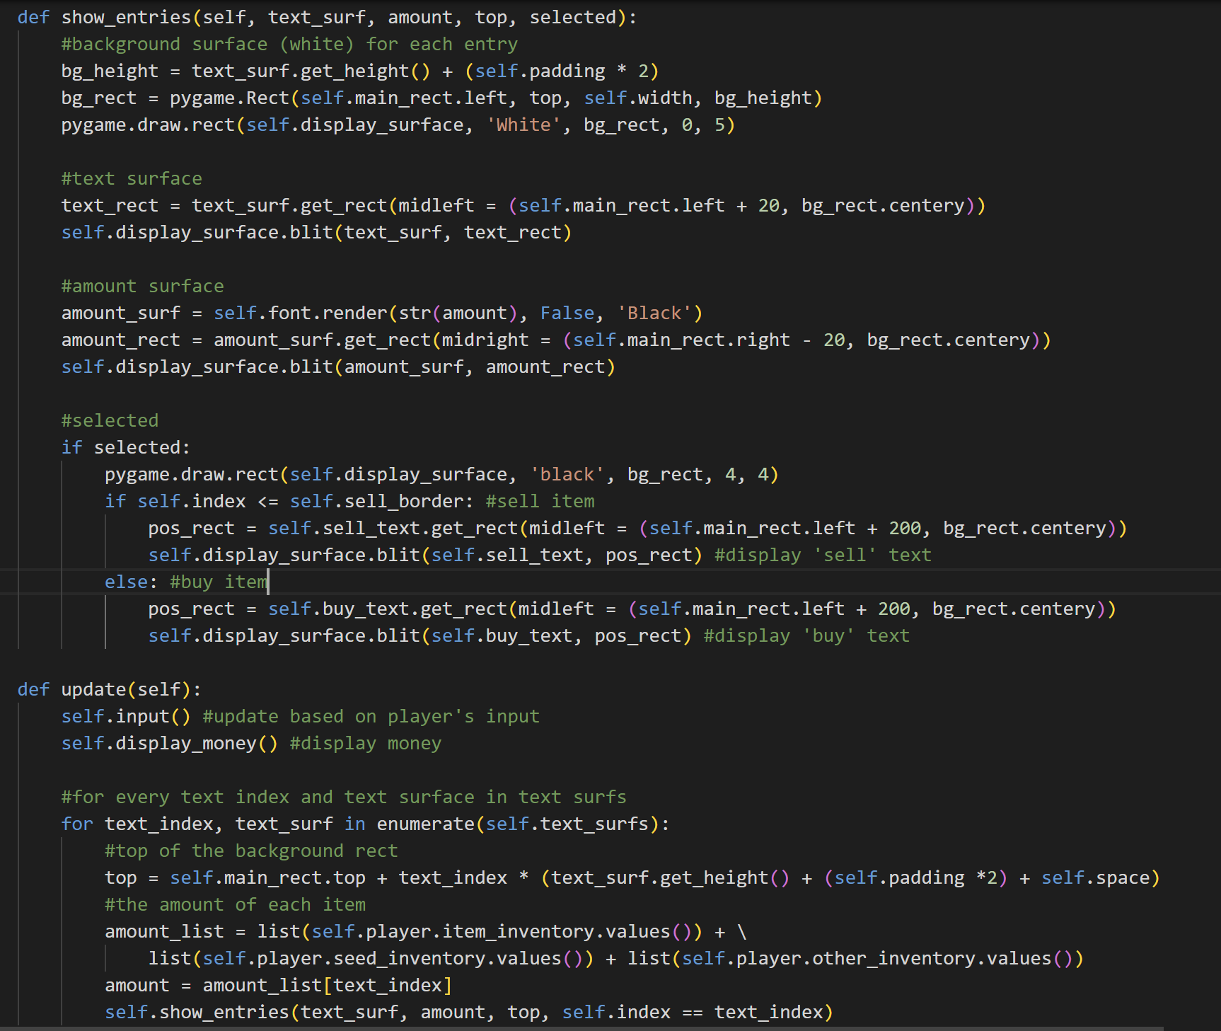

The show_entries method will first get the background height for each entry, get their rects, and draw them with white colour on the display surface. After that, it will also blit the text surface and text rect to the display screen (the name and price of the item). Then, it will also blit the amount surface and amount rect. If an item is selected, then draw a black rect as the border for the selected entry. If the index is lesser than the sell border, then get the position rects and display ‘sell’ text. Otherwise, display ‘buy’ text.



The update method is used to update the shop menu based on player input. It will also update the money by calling the display money method. The amount of every item also needs to be updated, so for every text index and text surface in the text surfs list, it will first get the top of the background rect for each entry and then from the amount list, it will get the amount of the corresponding item based on the text index. After that, it will call the show_entries method based on the up-to-date numbers.

1. **soil.py**

This file contains the class Plant, SoilTile, WaterTile, and SoilLayer. This file mainly handles the soil and plant systems in this game.

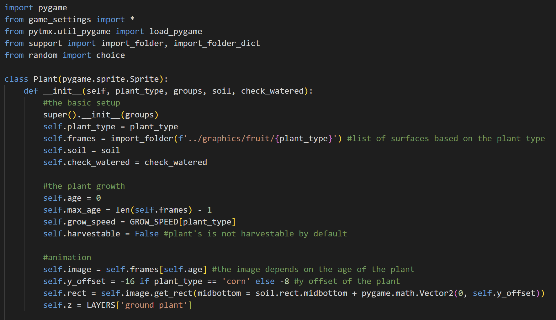

Import pygame, from game_settings, import all constants, from pytmx import load_pygame, from support import import_folder and import_folder_dict functions, and from random import choice.

* Class Plant

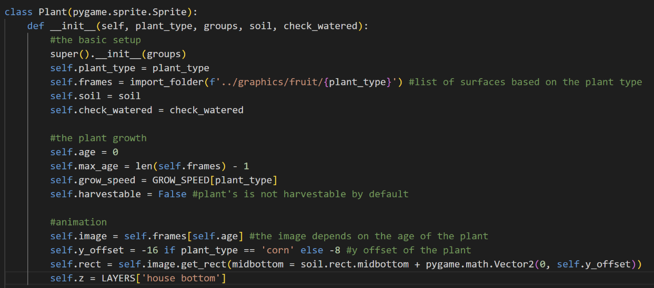

The Plant class is inherited from the Sprite class in pygame. There are several attributes upon creating a plant object, which is the plant_type (in this game, there are two, which are corn and tomato), frames (list of surfaces based on the plant type), the soil, the check_watered function, the age of the plant (initially 0), the max_age (the length of the frame minus 1), the grow_speed (depends on the plant type), the harvestable status (initially False), the image (that depends on the frames and the age), the y offset of the plant, the rect of the plant (depends on the image), and the layer.

Initially, the layer of the plant is the house bottom (equivalent to carpet) because it is still a seed, so the player can step on top of it. The y offset of each plant type is also different. The y offset helps to determine the rect of a plant because each plant has different shapes.

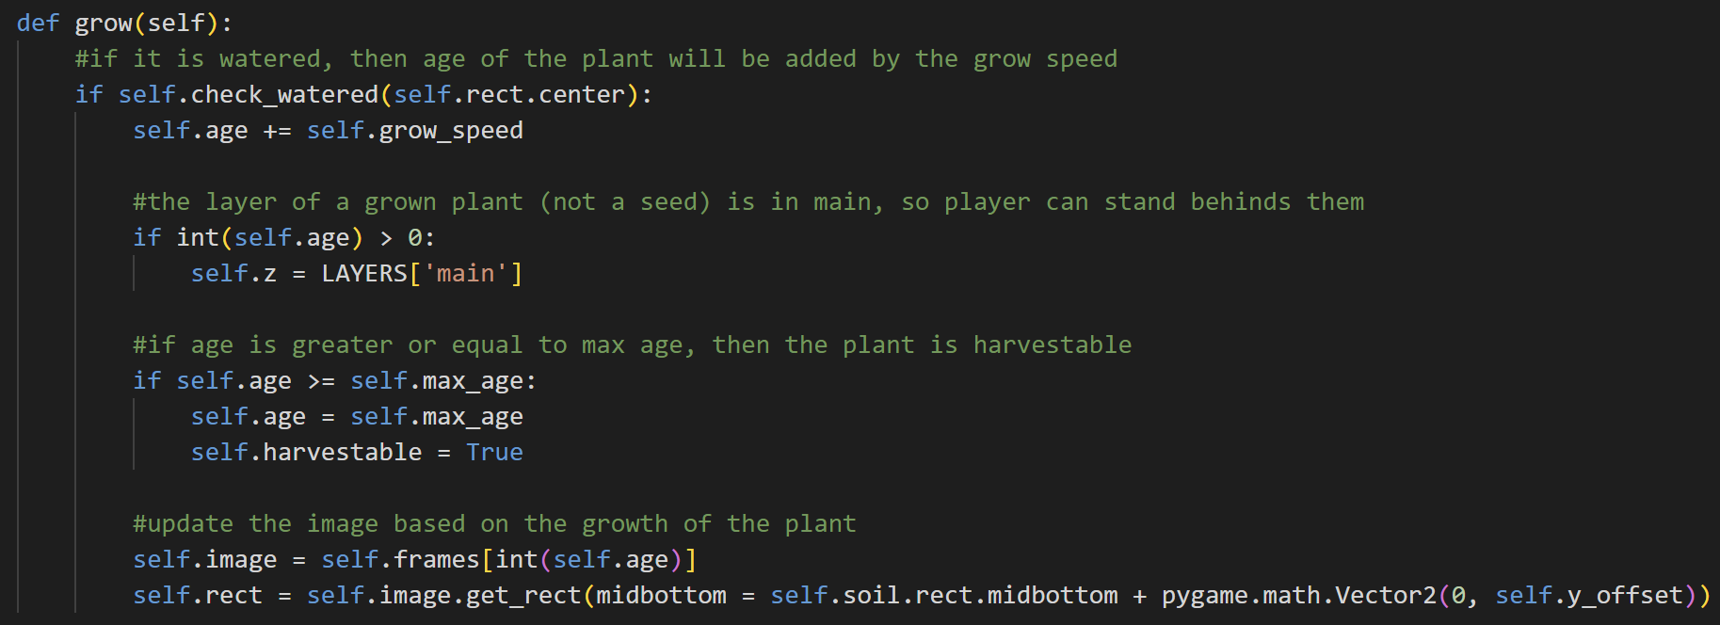

The grow method is used to grow plants. If it is watered, then the age of the plant will be added to the growth speed. If the plant is not a seed anymore, the layer will also become ‘main’ because they are not seeds or sprouts anymore, so they have quite a distinguishable height. If the age of the plant is greater or equal to the max-age, then set the age as the max age and the plant is harvestable. Based on the growth of the plant, this method will also update the plant’s image surface based on the age of the plant and gets it rect again.

* Class SoilTile

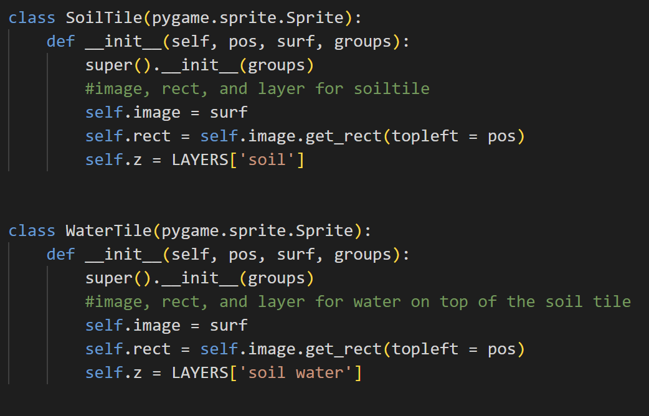

The SoilTile class is also inherited from the Sprite class in pygame. Objects of this class have the attributes images, rect, and the layer (z) is in the soil.

* Class WaterTile



The WaterTile class is also inherited from the Sprite class in pygame. Objects of this class have the attributes images, rect, and the layer (z) is in the soil water. It is higher in the layer than SoilTile because objects from WaterTile is actually the water tiles on top of the soil tile when the player waters the soil.

* Class SoilLayer